Grim Workshop
_____________________________________________________________

Our Story

Based on a fifth generation family farm in the heart of Texas, we’ve learned the value of self-reliance. We get dirty, sweat, swear - and just like our tools, we get the job done. Our idea was simple… what if you could condense the contents of an emergency kit into something that could fit in a pocket? After a trial run at a farmer’s market in 2015, the business quickly scaled to a catalog of over one hundred products and a passionate community of thousands of customers worldwide.

Our tools have raised over $200,000 on Kickstarter and were featured in the likes of American Survival Guide and Touch of Modern. We’ve recently been proud to offer a signature line of products in partnership with the winners of History Channel’s hit series Alone, as well as survival expert Bob Hansler.

Our Products

All of our tools are designed and engineered here in Texas, with everything manufactured in the USA. When it comes to the quality of our tools, we spare no expense and make no compromises. Each tool is manufactured in small batch runs, which allows us to constantly evolve and adapt our products to our users’ needs. Every product we make has three guiding principles:

- Be Compact - Our tools measure just 1mm thick on average and are designed to store perfectly flat.
- Be Reusable - A custom Tool Retention System allows any removable parts to return to their original position.
- Be Functional - Hardened for extra durability, we use only the highest quality 400 series surgical grade stainless steel across our entire line.

As a brand carried by soldiers, tradesmen, hunters and more, our line includes three sizes of tools to meet the unique demands of our customers:

Credit Card Tools
Grim’s credit card tools are designed to turn your wallet into the ultimate survival kit. Sized the same as a standard credit card, not only do they easily fit into a wallet or purse, but also feature an adhesive on the back. This allows you to utilize previously unused areas of objects like toolboxes and lids as gear caches.
These ultra-light, wearable tool kits are perfect for any bug-out-bag, emergency, survival, or EDC kit. Designed to go from the city to the wild, our credit card tools feature gear like fishing kits, spears and even a slingshot.

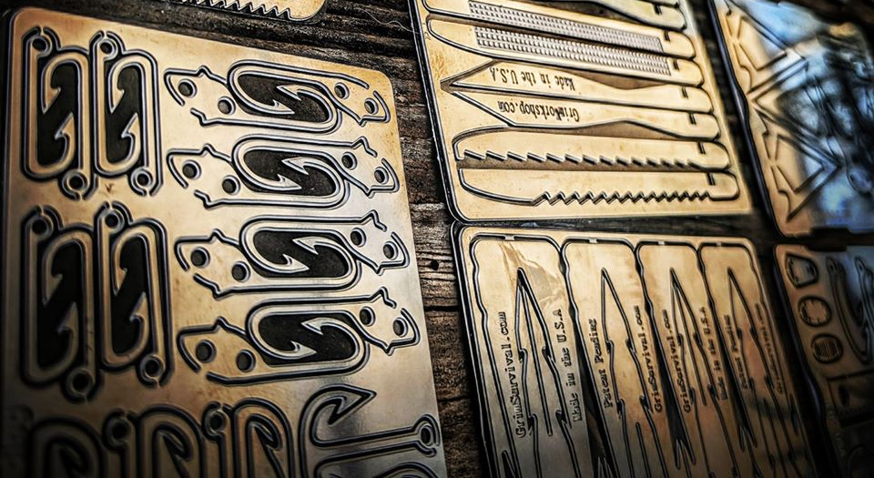

Dog Tag Tools
The same size as dog tags issued by the military, our dog tag tool kits are designed to be worn around the neck or kept on a keychain. Everything from wrenches and knives, to specialty tools like lock-picks, arrowheads and fire starters are available. At under 1mm thick, our dog tag tools are some of the smallest emergency, survival, or EDC tool kits ever created.

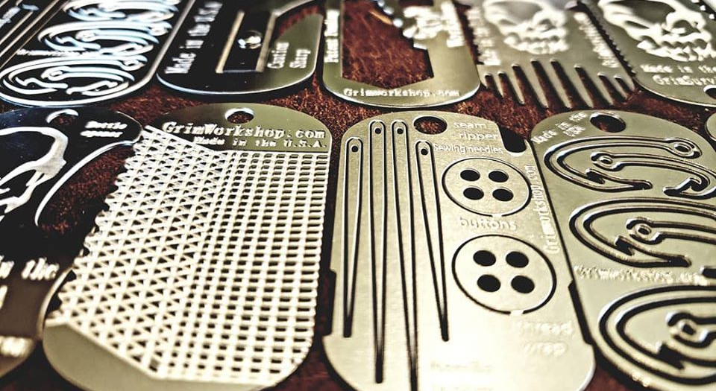

Micro Tools
The smallest kits in our line, Grim micro tools are designed to “equip it and forget it” on a range of items. At less than 2” long and 0.5” wide, the micro tools easily clip onto zipper-pulls, backpacks, keychains and more. Over 20 designs include things like sewing needles, box cutters and even escape keys that can stay on your gear at all times.

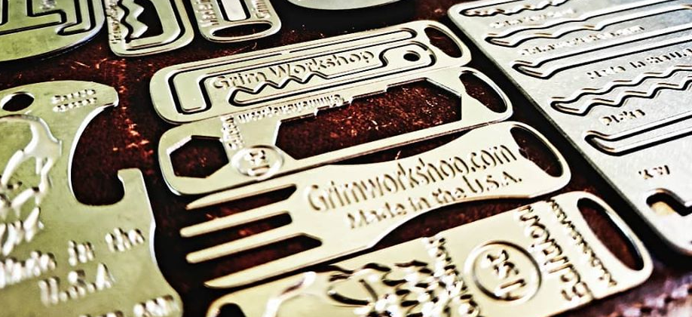

Our Mission

We aim to provide quality tools as unique as the people who carry them. Whether it’s a credit card tool stashed in a wallet, a dog tag tool around a soldier’s neck or a micro tool on a student’s keychain, Grim’s got you covered. Saving space, saving time or saving lives, we have a tool for that.

Grim Workshop - what’s in your pocket?

