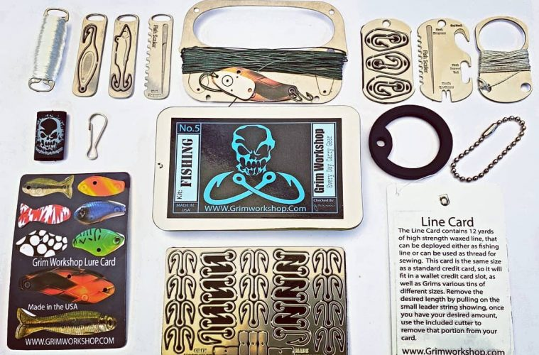

A FISHING KIT THE SIZE OF A CREDIT CARD
fishing kit accessories survival kit
4min read

They say give a man a fish and he’ll eat for a day. Teach a man to fish and he’ll eat for a lifetime. Well, what if that man forgot his tackle box that day? Knowledge can only get you so far without the tools to use it. That’s why carrying the right gear can be a real life-saver, especially when it fits in your wallet.
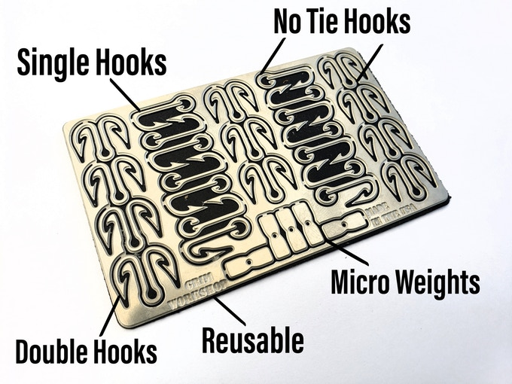
The micro fishing kit is the latest creation from Grim Workshop, the company responsible for the tool roll wallet. Having cornered the market on ultra-compact survival tools, their lineup wouldn’t have been complete without a fishing kit small enough to fit in one hand.
Their Kickstarter campaign offers three sizes of fishing gear, each somehow smaller than the last…

Credit card-sized
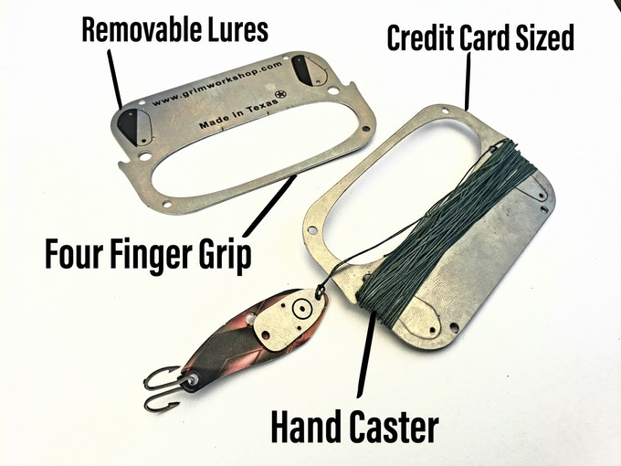
The largest option shares the dimensions of a VISA and promises a full tackle box worth of gear you can drop in a pocket. The kit contains everything necessary to fish on the go:
- credit card-sized hand caster
- lure card with 8 reusable lures
- line storage card that holds 36′ of fishing line
- specialty hook card equipped with 25 hooks

Dog tag-sized
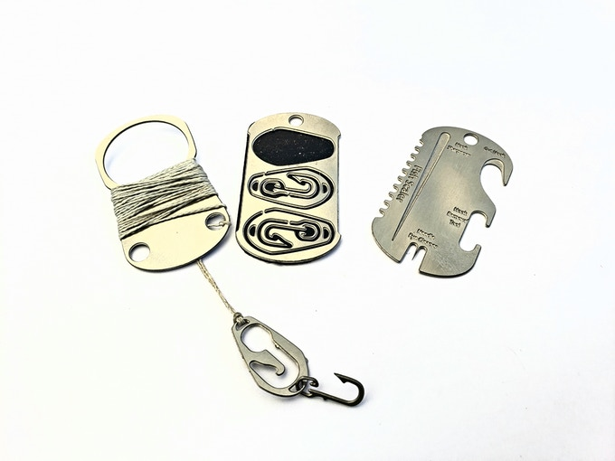
Designed to match the size of military issue dog tags, this fishing kit is small enough to fit on a necklace or keychain. A single finger caster is paired with a lure and hook combo piece that holds three hooks and three lures.
The third dog tag piece holds a scale remover, hook sharpener, gut hook and more.

Micro tool sized
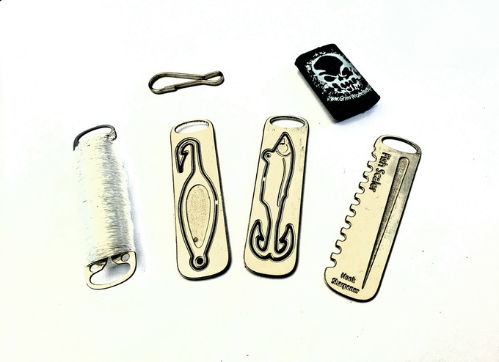
I can hear what you’re saying. “Surely, they can’t go smaller than a dog tag – it’s beyond the limits of modern science!” Well, they’ve done it. The smallest option is the micro tool fishing kit and it’s about the same size as a large paperclip.
Weighing only a couple grams, Grim managed to fit a 50′ line spool, two lures, a fish scaler and a hook sharpener down to just a couple inches.

Early bird pricing available
A range of pledge rewards are available depending on the fishing kit selected. The dog tag-sized kit starts at the early bird price of $18, scaling up to the complete package at $75.
Grim has four successful Kickstarter campaigns under their belt, making follow-through and fulfillment guaranteed. Their funding goal was met in the first few hours and orders are planned for delivery between December 2019 and January 2020.

