**Release: Immediate**

Contact: Mr. Kevin Shults

Director of Marketing

Hydromat, Inc.

11600 Adie Road

St. Louis, MO 63043

Phone: 314.432.4644

Fax: 314.692.9186

kshults@hydromat.com

**The Hydromat Rotary Transfer Machine Lowers Precision Part Making Costs with Multiple Innovations**

***ST. LOUIS, MO*** - Hydromat Inc. is the industry leader in the design and manufacture of precision rotary transfer machines and mill/turn centers for the precision metal cutting marketplace. For 39 years, Hydromat has had a reputation built on a commitment to quality, customer service, and technological innovation. No other precision machine tool manufacturer is more ideally suited to increase production and profit potential than Hydromat—your flexible solutions partner. Inside our North American headquarters are 175,000 square feet of vertically-integrated manufacturing expertise, along with our dedicated workforce, ready to take production throughput to unheard of numbers. Hydromat’s on-site capabilities range from design and engineering excellence to the machining and fabrication of the parts and tooling made from the finest materials that make up the final product.

The Hydromat rotary transfer machines feature a modular system consisting of as many as 16 horizontal and 8 vertical toolspindle units, rigidly mounted around a precision cast base with high-precision machining of all critical surfaces. This arrangement has the capability of providing tremendous versatility and flexibility in a turnkey machining system. The precision ground Hirth ring assures table accuracy and reliability from station to station to within 0.0002". Hydromat’s non-rotating bar stock design provides quiet, vibration-free operation.

***The Hydromat Rotary Transfer Machine Lowers Precision Part Making Costs - Page 2***

Typical components ideally suited for machining on Hydromats include automotive ABS and brake systems, high-pressure fuel, electrical, air conditioning, engine, and steering components.

New updated EPIC II machines feature the latest in CNC rotary transfer technology. This second iteration of the EPIC platform boasts advancements such as enhanced operations, production reporting, down time analysis, trouble shooting, and preventative maintenance interval scheduling. EPIC II utilizes a Bosch CNC/PLC common control. These features, among others, will yield improved part set-ups, changeovers, process-tooling development and integrated tool monitoring. An upgraded servo control features absolute positioning, and a more efficient architecture that reduces failure points.

EPIC II is a streamlined version of the plug n’ play control architecture embedded into each toolspindle unit that offers the highest possible degree of performance and flexibility including complex multi-axis operations. The elimination of the previous PMAC EPIC boxes streamlined the electronics featuring the finest of today’s technology, resulting in reduced wiring and machine plugs as well as common servo valves. A new, more economical unit motor saves costs.

The New Eclipse 12-100 is a ground up re-design of the famous Hydromat concept with all new components. The machine has a heavy casting mounted on a frame of sturdy, welded, steel construction. The machine casting is 2m in diameter, nearly twice as large as the traditional 12 station Hydromat machine. This new ductile iron casting is designed for the use of semi-permanent tool spindles, each having 3-axis capability as standard; eliminating the need to change tool spindle sizes for different cutting processes or adding 3-axis flanges for that capability. The new Eclipse features all electric servo spindles and slides. No hydraulics are needed for tool spindle motion as in previous

***The Hydromat Rotary Transfer Machine Lowers Precision Part Making Costs - Page 3***

Hydromat machines. These new technologies along with the beefier base yield better accuracy and repeatability.

The bar fed collet version of the Eclipse 12-100 has a maximum workpiece diameter of 65mm (2.5”) and features a maximum workpiece length of 180mm (7”) with 127mm (5”) of material outside the collet. The Eclipse will also be available in an Indexing Chuck version that will feature a table with vertical chucks capable of 360° rotation of the workpiece. This system is ideal for mid to high-volume, precision production of irregular-shaped castings or forgings and is designed with the flexibility to easily accommodate families of parts.

ICON Technologies, a Division of Hydromat, provides unique multi-station mill-turn centers—the ICON 6-150, ICON 8-150 and ICON 6-250—to the precision metal cutting marketplace. Designed with four to six machining stations and dedicated loading/ unloading stations, the ICON line was developed around flexible machining principles. Equipped with a six or eight position table, they shuttle pallets to machining modules for fast, ultra-precision cutting. Each spindle type is selected based on the type of

cutting to be performed. ICON offers high-torque spindles in; 10,000-rpm, 20,000-rpm, 42,000-rpm, and 60,000-rpm configurations. Spindles are air-purged and liquid-cooled, permanently grease-lubricated, and are virtually maintenance free. ICON machines are equipped with servo driven, direct drive B-axis motors. END

(more)

***The Hydromat Rotary Transfer Machine Lowers Precision Part Making Costs - Page 4***

Sales Contact: Mr. Matthias Walter

President

Hydromat, Inc.

11600 Adie Road

St. Louis, MO 63043

Phone: 314.432.4644

Fax: 314.432.7552

For more information, visit our website: [www.hydromat.com](http://www.hydromat.com)



**The Hydromat Rotary Transfer Machine Lowers Precision Part Making Costs - Page 5**

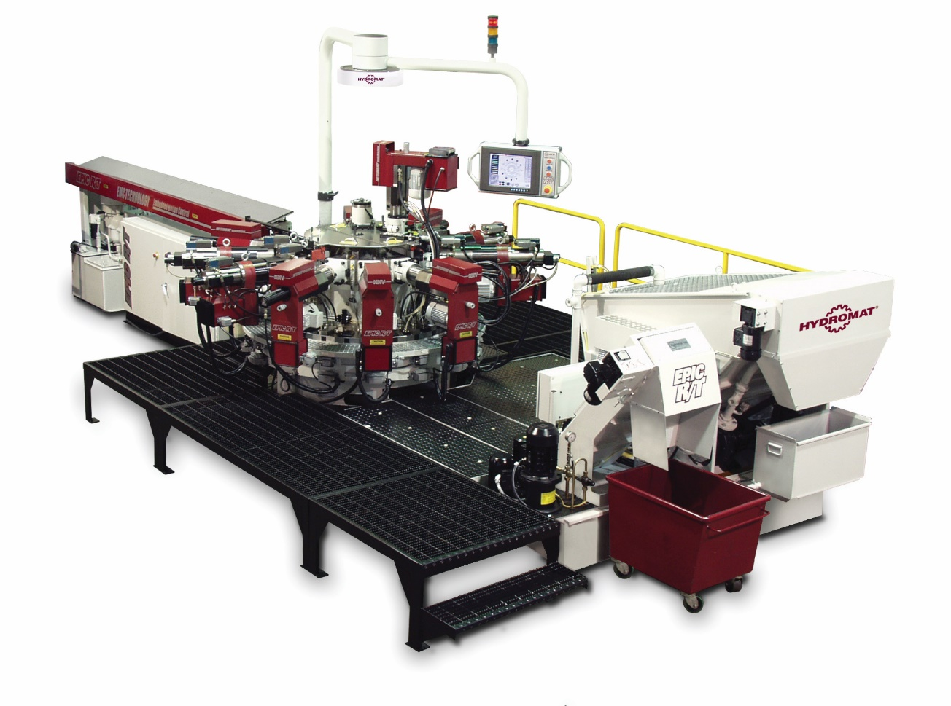

*Caption:*  The Hydromat Rotary Transfer machines produces precision metalcutting for bar-fed applications. Some models utilize up to 16 horizontal tool spindles and the capacity of up to 8 vertical tool spindles, featuring up to 24 tools in the cut at once. 

**The Hydromat Rotary Transfer Machine Lowers Precision Part Making Costs - Page 6***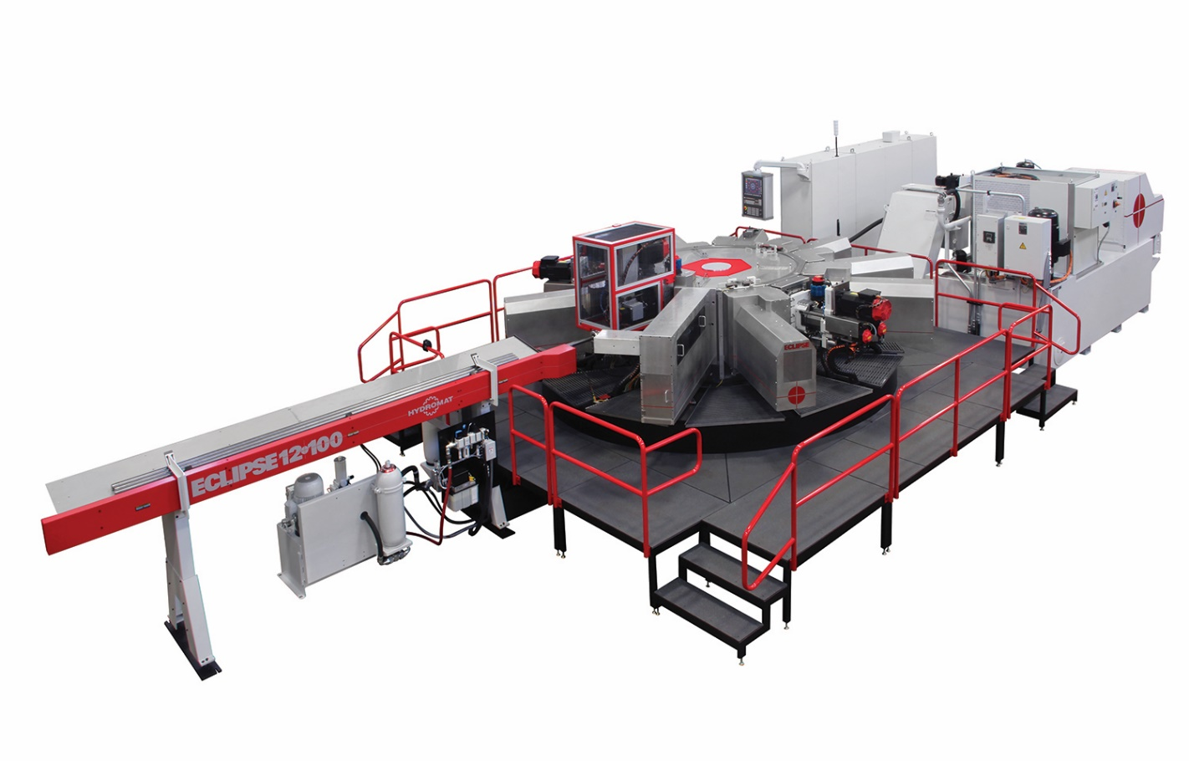*

*Caption -* Hydromat Inc. recently introduced the new Eclipse 12-100, a unique 12 station Rotary Transfer machine with much larger size capacities than ever before.

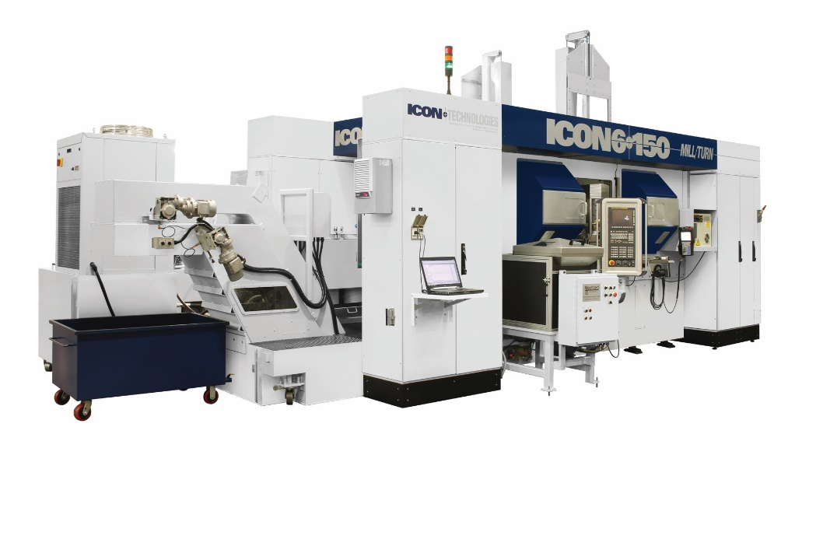

*Caption:* ICON Technologies, a division of Hydromat Inc., introduces the ICON 6-150 Mill/Turn Center, a precision metal cutting machine that combines flexible Lean principles with a pallet transfer system for increased production and profit.