Multi-process module by EMAG ECM:

Electro-chemical efficiency lifts automotive mass production to a new level

The idea behind the “platform strategy” in automotive production is as simple as it is effective: The manufacturers no longer construct completely unique engines, transmissions, and components for every model, but instead use numerous “common components” for similar vehicles. This results in a massive increase in unit volumes, and a decrease in the development and unit costs. However, the consequent boom in production requires an answer to the question of what technologies can possibly manage the growing unit volumes efficiently—especially when many of those components need to be machined with ever greater precision then previously required. It was exactly this situation that led EMAG ECM to develop a new machine concept that unites innovative electro-chemical machining (ECM) with the demands of the fast-paced mass production of automotive components. The new ECM machine with the multi-process module (MPM) has already been successfully implemented into operation with an automotive supplier, where it produces high-quality injectors for car engines by the second.

The potentially crucial challenge for automotive production today is summed up well by the keywords “quantity and quality.” Every part has to be created with high precision and must leave the machine with no defects. At the same time, individual machining steps sometimes need to be completed in just a few seconds. The fuel injector in a diesel engine is a good example: Each six cylinder model has six injectors, and the same injector is used in a range of different engines. Consequently, a very large number of the injectors are manufactured by automotive suppliers in an OEM's manufacturing network—and every one of them must be machined with very high precision, so the fuel injection process will be performed with that same degree of precision. How can the growing production volumes of injectors be managed even more efficiently now? “We had these and similar components in mind when we began the development of a new ECM machine,” explained Peter Loetzner, President & CEO at EMAG L.L.C. “Our main goal was to integrate as many sub-processes as possible in a single machine—including various ECM stations, the automation system, and final rinsing and protective coating. The process modules used for this purpose can be flexibly adapted to the task, both in functionality and number. All of these processes are interlinked by the integrated automation system. At the end of the process, perfect parts emerge from the machine.”

Short distances—small footprint
This approach presents the user with a range of obvious benefits: First, the all-in-one design of the machine takes up little space, as sub-processes such as washing are no longer performed in external units. Second, the distances that the parts have to cover inside the compact machine are very short. Moreover, the parts are moved from one module to the next by an integrated linear axis handling system. However, the Bosch Rexrodt handling technology used had to be specially adapted for the purpose, with the aim of cutting the necessary installation space in half when compared to previous systems. This was necessary to keep the machine compact. This technology also features high dynamics and precision. As a result, the parts pass through the modules in a cycle measured in seconds.

Which washing and ECM modules that are used on the machines depend on the requirements of the component to be manufactured. So EMAG ECM configures the MPM machine individually for each customer. There might be, for example, four ECM stations in the standard model, with possible expansion up to six ECM stations. Every one of the stations could be capable of machining four, eight, or twelve parts at the same time. One available option is to perform one ECM sub-process on the part in each of these stations (e.g. OP 10, OP 20, OP 30, and OP 40), while another option is to run the same process in parallel (e.g. 4 x OP 10) in order to increase the machine's output even more. In all cases, users benefit from the immense advantages of electro-chemical machining. For instance, the wear on the tool in use is minimal. There is also no thermal damage to the workpiece. This is made possible by an almost contactless technology: A direct current or pulse is used to polarize the workpiece positively, to create an anode, and the tool negatively, for the cathode. An electrolyte solution flows between the two, and metal ions detach from the workpiece. Because the shape of the tool cathode mirrors the desired workpiece geometry, material is removed only in the areas desired. This approach greatly simplifies the process for a whole range of components, because the burr-free ECM technique requires no finishing work. “That is a tremendous advantage because the customer can save the cost of buying deburring machines and needs less space on the production floor,” Loetzner said.

Many possible applications in automotive manufacture
In the case of the fuel injectors, the diverse advantages of the new ECM machine with multi-process module are already being demonstrated in practical use. The machining of each injector takes just 15 seconds, with four parts at a time being transported in parallel through the four ECM stations, two washing stations, and one protective coating station installed in the machine. The process also achieves an almost unimaginable level of precision. What other components could be machined in an individually configured MPM machine? “The suitable range of components from automotive manufacturing is very large,” Loetzner said. “It includes turbine wheels and turbine housings, cam elements, pistons, and various transmission elements such as synchronizer hubs and drive shafts. Depending on what is required, ECM can then be used for machining of the surface, drilling and broaching operations, or deburring.”

With high unit volumes, high precision, and a small footprint, it's no wonder the experts at EMAG ECM are convinced that the MPM concept will be successful. The general trend toward higher unit volumes in automotive production is, in a sense, heading in the direction of this concept. It is also possible to imagine a compact MPM ECM machine forming part of a larger process chain of EMAG machines. This chain might go from turning and grinding through to subsequent ECM deburring or ECM broaching. “The compact design of our new technology opens up a whole new range of possibilities here,” Loetzner remarked in conclusion.

Image captions:
Image: E440.jpg
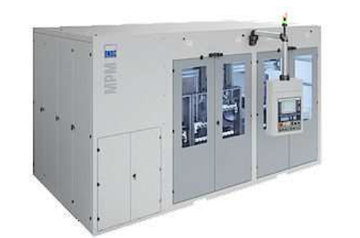
The new MPM machine by EMAG ECM: a multitude of processes is performed on the part in a very small space.

Image: ECM_Principle.jpg
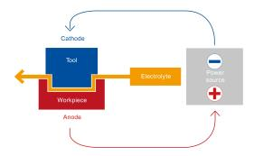
Simple basic principle, great effect: workpieces immersed in an aqueous electrolyte solution are machined with the utmost precision by means of a charge exchange between a cathode and an anode.

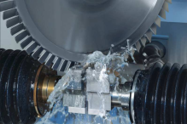
Image: C269.jpg

Users benefit from tremendous ECM advantages. For example, wear on the tool in use is minimal, even when machining extremely hard materials, as seen here in the machining of a blisk. There is also absolutely no thermal damage to the workpiece and the machining result is precise to the micrometer.

Image: raw_part.jpg / finished_part.jpg
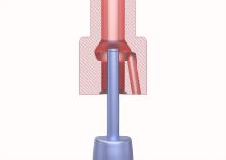
In the case of the fuel injectors, the diverse advantages of the new ECM machine with multi-process module are already being demonstrated in practical use. The machining of each injector takes just 15 seconds.

Contact for press and publications
Markus Isgro
EMAG GmbH & Co.KG
Austrasse 24
D-73084 Salach
Phone: +49(0)7162/17-4658
Fax: +49(0)7162/17-199
E-mail: misgro@emag.com
www.emag.com

