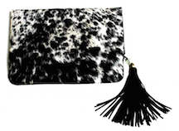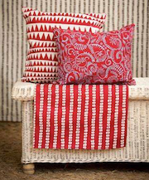

FOR IMMEDIATE RELEASE
Contact: Susan Bibbings – 1-778 840 9229 – susan@lotuslandimports.com

2016: The Year of the Eco-savvy Consumer
Lotusland Imports showcases sustainable luxury at NY NOW, Javits Center, NYC.

January 12, 2016 -- Not so long ago, Fair Trade accessories were synonymous with a rough-hewn, Earth Mother aesthetic. How times have changed! Today, globally aware women seek elegant designs suitable for boardroom and beach party alike. They want luxury accessories that make a statement – and a difference in the world.

But can high fashion be sustainable? Lotusland Imports shows us how.

Lotusland Imports is Fair Trade with a difference.
- This impressive collection of handbags, jewellery and textiles is a collaboration between European designers and African artisans. Milan’s prestigious Istituto Europeo di Design helms the jewellery collection. “The beauty of it,” says owner Susan Bibbings, “is that innovation is encouraged while techniques and materials remain traditional.”

Lotusland Imports is eco-ethical.
- By providing earth-friendly, creative jobs, Lotusland Imports prevents deforestation and land destruction. Their tannery upcycles cowskins that were previously discarded and handcrafts them into gorgeous handbags.

They put people first.
- Instead of remote factory production, working parents stay together to raise their children while attaining self-sufficiency. Bibbings explains: “The artisans have registered their own cooperative and bank accounts and are setting up spinoff microbusinesses to generate future income. Some of the women are becoming landowners for the first time.”

With Lotusland Imports, one needn’t sacrifice high style for sustainability any longer. Learn more about them on Facebook, Instagram and this video.

Shop Lotusland Imports online or visit them at: NY NOW Javits Center, NYC, January 30 through February 2, River Pavilion, booth 338. Category: Handmade Global Chic.

