PRESS RELEASE
For Immediate Release

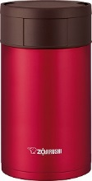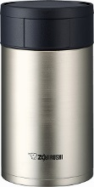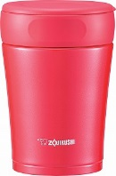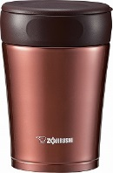

NEW STAINLESS STEEL FOOD JARS
19 oz. SW-HAE55 and 12 oz. SW-GCE36

Torrance, CA (January 14, 2016) – Zojirushi has added new food jars to its line of best-selling vacuum insulated food containers. The Stainless Steel Food Jar (SW-HAE55) is available in a large 19 oz. capacity, the perfect size for holding hot meals, soups, oatmeal and much more. All of Zojirushi’s vacuum insulated products are made of high-quality stainless steel and these food jars have an electro-polished SlickSteel® interior that resists corrosion and repels stains. The SW-HAE55 is available in Metallic Red and Stainless finishes, and carries a MSRP of $50.

The Stainless Steel Food Jar (SW-GCE36) has a modern angled design that takes up minimal space, yet maximizes capacity. Its flat interior design makes it easy to eat and drink. Two new colors have been added to this line; Cherry Red and Nut Brown. Available now, the SW-GCE36 is available in a 12 oz. capacity, and carries a MSRP of $50.

Zojirushi’s Stainless Steel Food Jars provide a useful way to safely pack lunch when a microwave or refrigerator may not available. The tight-fitted lid with gasket seals to minimize leaks and maximize heat retention. The large openings on both models of food jars, make it easy to fill and clean, and allows for eating directly out of the jar. And the food jars are made of BPA-free plastic and stainless steel to ensure food safety. Both models come with a removable plastic cover around the mouth for eating and drinking comfort, and a gasket on the lid to release pressure, making removal of the lid easy.

About Zojirushi
Zojirushi was established in 1918 as a producer of hand-blown vacuum bottles and has been a world leader in thermal products ever since. The Zojirushi line has been expanded to include a wide range of stainless steel vacuum bottles, rice cookers, breadmakers, Air Pot® beverage dispensers, thermal serving carafes, specialty cookware, small electrics, restaurant equipment, and other products. Today, the Zojirushi corporate logo is a symbol recognized worldwide for innovative, highly durable products that are designed to make indoor and outdoor living a more convenient and pleasurable experience.

For more information on the entire quality Zojirushi Product Collection, contact Zojirushi America Corporation at 800.733.6270 or visit www.zojirushi.com

On Facebook: http://www.facebook.com/zojirushiusa
On Twitter: @ZojirushiUSA

###

For more information:
Krista Erickson
pr@zojirushi.com
310.558.8627

