PRESS INFORMATION | 

WILDLIFE WORLD DEBUT AT NEW YORK GIFT SHOW

Wildlife World UK, Booth 6409, New York Now Trade Fair, Javits Centre NYC, 21-14 August 2016

Wildlife World, a UK based leading manufacturer of sustainable wildlife products, is exhibiting at the New York Now Trade Fair for its first trip to the city.  The company returns to the US for the second time this year having exhibited at the National Hardware Show in Las Vegas in May. Over the past few years Wildlife World has expanded its presence in the US and is working with some of the largest retailers and distributors to offer its wide range of sustainable, wildlife-friendly products to the market.  To celebrate its first time exhibiting at the show, Wildlife World is giving away a ‘Save the Bee’ Rescue Pack as part of its campaign for the conservation of solitary bees, a friendly and very beneficial species for pollination. The promotion, running at the company’s booth, number 6409, gives one visitor the chance to win a ‘Save the Bee’ Rescue Pack to demonstrate just how easy it is to provide a suitable habitat to save the species from declining. A 20% discount voucher* will also be awarded to the winner for their first purchase with Wildlife World, and 10%* will be awarded to one runner up.  Within the pack is Wildlife World’s Education and Observational Solitary Beehive that is both a working habitat for the species and a great, high quality product for observing the nesting habits and lifecycle of solitary bees. The beehive is a triple chamber habitat and includes various nesting features, which can be removed or accessed for study and observation. The drilled canes will also attract many other beneficial garden insects, which also help to promote a thriving garden. In particular, the beehive features a stackable hive with removable trays to allow egg cells to be examined.  Wildlife World’s Ceramic Bumblebee Nester is also included within the pack to offer a suitable home for the species as they do not share the same habits as solitary bees. This particular habitat provides a larger open space for the species to swarm inside.  The bee rescue pack also includes a pack of bee management tubes to allow the winner to create their own solitary bee habitat. | 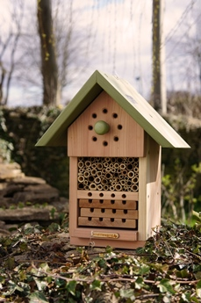  Image 1  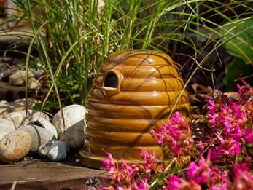  Image 2  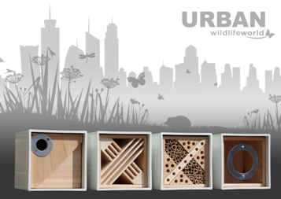  Image 3  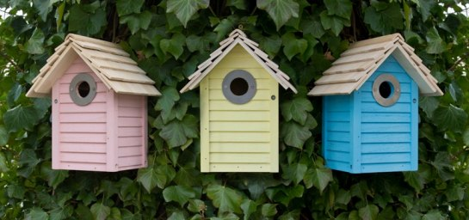  Image 4  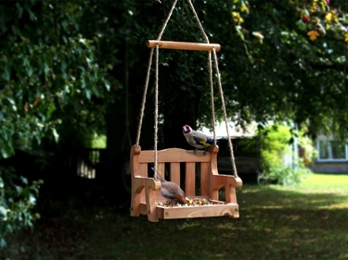  Image 5
The Education and Observational Solitary Beehive, along with other great products for the species including the Bee & Bug Biome and Pollinating Bee Mug are all part of the company’s growing range of bee habitats specially designed to provide a safe nesting place using the specially designed wooden tubes. The attractive designs and beneficial qualities of these products make them a very popular gift for all garden and wildlife lovers.
The company is committed to the conservation of species such as solitary bees and other beneficial garden insects, as well as garden birds, amphibians and small garden mammals. It is this commitment and determination to provide homes and products that are safe and valuable to these species which has earned the company its market-leading position in Europe.
A wide range of Wildlife World’s products will be displayed on the company’s stand at the NY Now show, including the award winning Urban Range for insects and birds. Comprising a bird nest box, feeder, butterfly house and bug house, the Urban Range was designed by Wildlife World to provide a habitat and feeding source for areas where very natural sources are not available. The design of the boxes, made from recycled plastic and sustainable timber, deliberately complements the aesthetics of city and urban environments, allowing wildlife lovers to attract their favourite species in these limited areas.
Other nest boxes will also be on display on the stand including Wildlife World’s colourful New England range. Available in pastel pink, lemon, blue and green, the nest boxes are based on New England beach huts making them a fun and delightful addition to any garden. Like the Urban Range, Wildlife World uses only sustainably sourced wood and water-based paints and sealants to create the boxes to ensure that the nesting birds are not exposed to any harmful chemicals.
Wildlife World also offers a delightful selection of bird feeding tables, which make a great accessory for all gardens and can be viewed on the company’s stand. The Swing Seat Feeder is a particularly popular product for feeding birds due to its striking rustic design based on the swinging garden chair. The open structure of the feeder allows gardeners to observe the birds whilst feeding. The feeder is very user friendly as it features a removable feeding hygiene tray which makes it very easy to clean and can be easily suspended from trees or other tall objects.
The Bempton Hanging Bird Table is another favourite due to its intricate lattice detail and attractive colours. Like the Swinging Seat Feeder, the Bempton table also features a removable feeding tray so that it can be kept clean and can be used for all types of food and bird species.
All of Wildlife World’s products make a great gift for all types of interests and lifestyles, with both hands-on active products, such as the customisable biomes and insect houses, and ready-made bird boxes and feeders available. To find out more about the company’s full range of gifts and products, visit them at booth 6409 at the show where you will also have the chance to enter the Solitary Bee competition!
Further information is available from Wildlife World on +44 1666 505333, by emailing james@wildlifeworld.co.uk or by visiting the company’s website at www.wildlifeworld.co.uk

Ends. Wildlife World48 24 June 2016
Notes to editors:
*Purchase not necessary to win competition.
For further editorial information contact James Allan of Wildlife World on +44 1666 505333, email james@wildlifeworld.co.uk or Chloe Walters of Vantage PR on 01600 715251 or email pr@vantage.uk.com

For colour separation requests please email Brenda Christopher at brenda@vantage.uk.com or fax +44 1600 715254.

Issued on behalf of Wildlife World Ltd, Manor Farm Barn, Chavenage, Nr. Tetbury, Gloucestershire, GL8 8XW UK, by Vantage Public Relations, 14 White Swan Court, Monmouth, NP25 3NY, UK, www.vantage.uk.com
CAPTION FOR IMAGES 1 & 2: To celebrate its first time exhibiting at the NY Now Trade Fair, Wildlife World is giving away a ‘Save the Bee’ Rescue Pack as part of its campaign for the conservation of solitary bees, a friendly and very beneficial species for pollination. Within the pack is Wildlife World’s Education and Observational Solitary Beehive (image 1) and Ceramic Bumblebee Nester (image 2).
CAPTION FOR IMAGE 3: A wide range of Wildlife World’s products will be displayed on the company’s stand at the NY Now show, including the award winning Urban Range for insects and birds.
CAPTION FOR IMAGE 4: Wildlife World’s range of bird nest boxes will also be on display on the company’s stand at the NY Now Gift Fair, including the colourful New England range. Available in pastel pink, lemon, blue and green, the nest boxes are based on New England beach huts making them a fun and delightful addition to any garden.
CAPTION FOR IMAGE 5: Wildlife World offers a delightful selection of bird feeding tables, which make a great accessory for all gardens and can be viewed on the company’s stand at the NY Now Gift Fair. The Swing Seat Feeder is a particularly popular product for feeding birds due to its striking rustic design based on the swinging garden chair.

