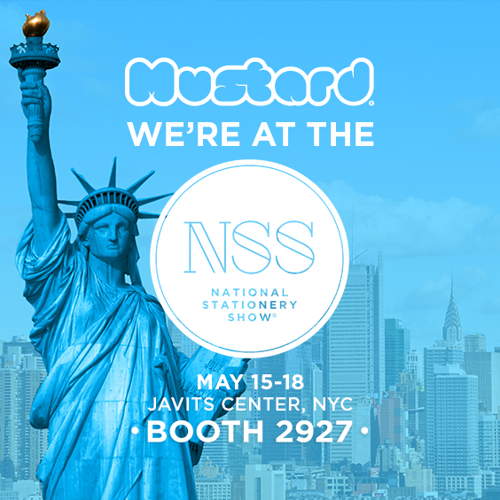

Mustard at NSS – Come see us at Booth 2927!
Mustard are thrilled to be back at the National Stationery Show this year. Our range is designed to put a smile on your face by brightening up your desk. So stop by our booth to discover a range of products that truly elevate the everyday.
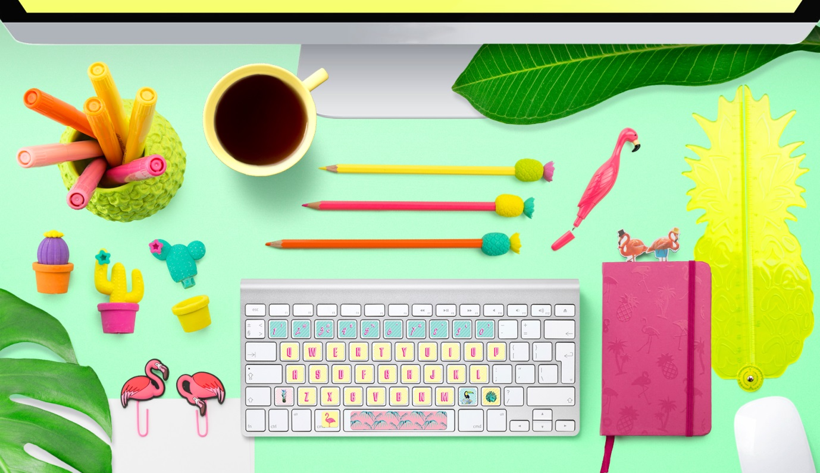

It’s been a busy year for us at Mustard, fresh from the UK we have been launching over twenty new stationery products from pineapple pen pots to cactus erasers and flamingo pens and we’re delighted to be showcasing our range at the National Stationery Show.
With the current Rio inspired tropical theme in mind, we’ve created a number of bright and vibrant products that we think sit beautifully on any desk and transport you to warmer climes. Our tropical theme has proved to be particularly popular in the UK where it has been featured in Stationery Magazine…
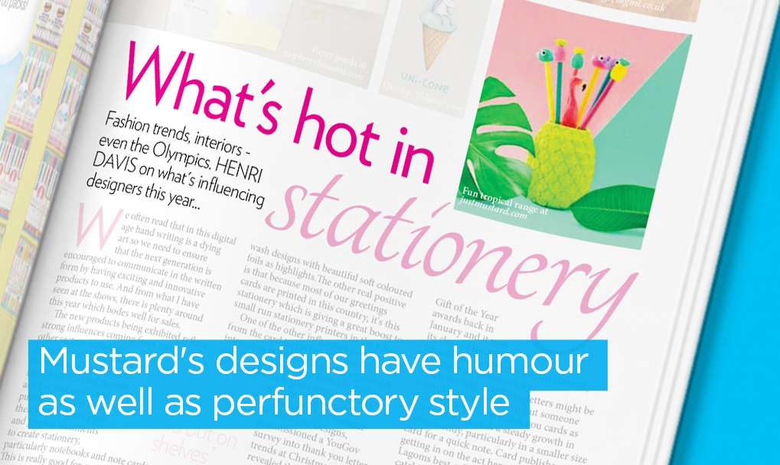

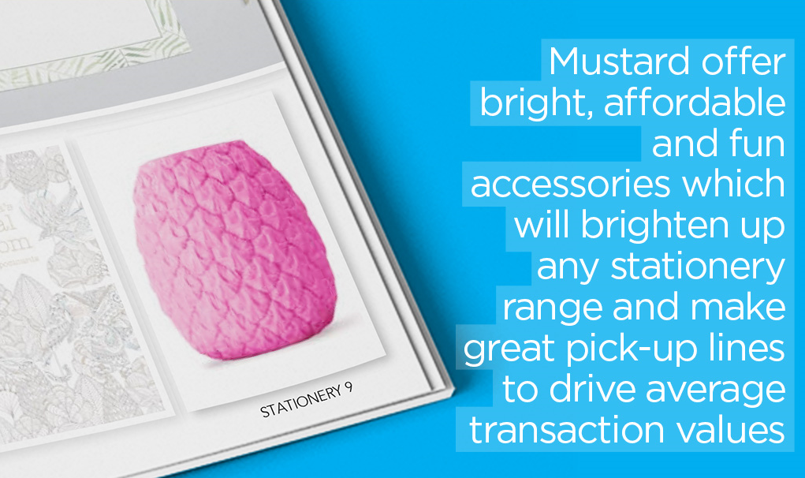

Coming up with fun and vibrant stationery is what we do. In-fact since Mustard started over five years ago, we have continually come up with new and exciting stationery ideas that are bold, bright and packed full of colour. See below for a selection of products you can expect to find at Booth 2927 this year.
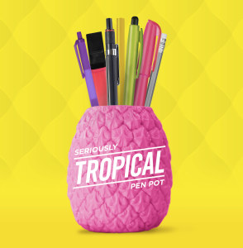
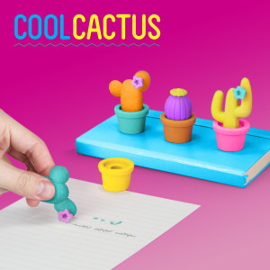
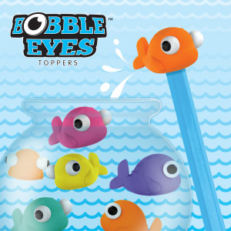
Our Bobble Eyes Eraser Pencil Toppers and Cool Cactus erasers are already proving extremely popular.
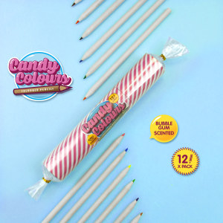
Our Candy Colors Coloring Pencils are bubble gum scented and come with unique candy themed packaging; meanwhile our Seriously Tropical Pen Pot won a commendation for desk accessories at the London Stationery Show!
For more information on Mustard, Contact Juliana Giliberto on (866) 444 1273 or via email (Juliana@justmustard.com) – Mustard 27-47 80th Street, Jackson Heights, NY 11370

