NEWS FROM MANUSCRIPT – NATIONAL STATIONERY SHOW 2016
Manuscript Pen Company has added exciting items to its Callicreative range: StyluScript Pen, calligraphy pen and stylus for tablets, which comes with a brand new FREE Calligraphy App; a set of 10 duo tip markers perfect for creative lettering and doodling and two inspiring craft sets.
Manuscript also offers new luxury writing paper sets and a new sleek Masterclass set. All this in preparation for the launch of Manuscript’s ‘Hero’ later this year: ML1856, an exquisite fountain pen which combines five generations of British craftsmanship with contemporary designs. Come and see us to discover more!
Visit us online at www.calligraphy.co.uk

manuscript@calligraphy.co.uk
T: +44 (0)1746 861236
More info and images here below.
STYLUSCRIPT: a new digital experience
For a richer writing experience, use the stylus pen on paper and your tablet. Two options available – fountain pen with iridium nib or 3 pen set.
Free Callicreative app will be soon available for download on Android and Apple tablets
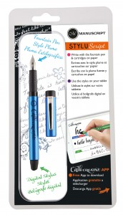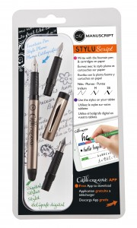

CALLICREATIVE CRAFT SETS
The Christmas creation set launched last year has got a new craft companion, the calli creation set suitable for creating projects for many occasions (Easter, mother’s day, birthdays etc.). These New craft sets have everything you need to create beautiful writing and wax sealing projects for special occasions. Delight and surprise your friends and family with hand-made personalised wrapping, lovely cards and tags. You will find in the box our new Stylus fountain pen with cartridges, Callicreative markers, a wax seal set and a calligraphy leaflet. Paper, parcel and tag templates are ready to be downloaded on line.
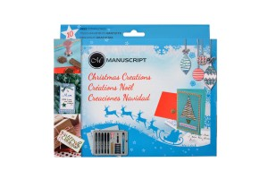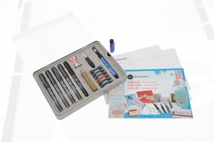
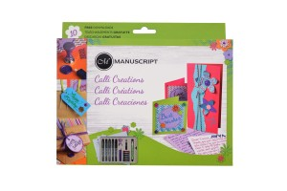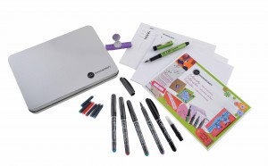

DUOTIPS
The funky double ended markers are perfect companions for hand lettering, doodling and colouring. Have fun!
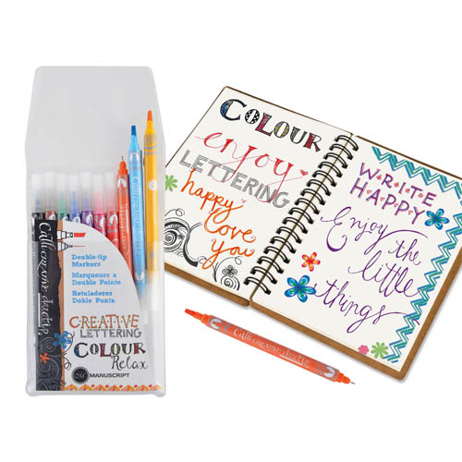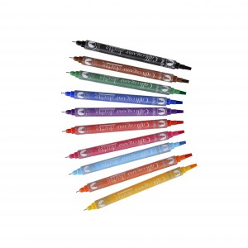

MASTER RANGE
Have a look at the additions to the Master range!
The New Masterclass set is the perfect gift for budding calligraphers.
Why not buy the co-ordinated stylish Master Parchment Paper and Black ink to complete the Master range?
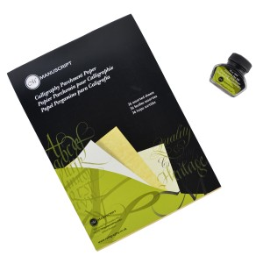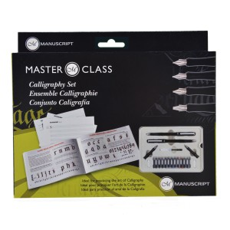
LUXURY PAPER SETS
Fine Paper and envelopes for fine writing. Another beautiful gift to complement the Master range.
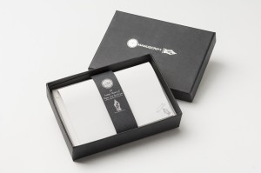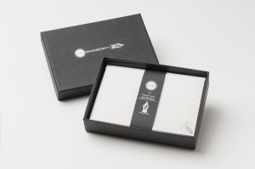

CALLIGRAPHY ARTIST SET
This finely finished wooden box set has been designed for calligraphers, artists and art lovers alike. It offers 12 selected nibs presented in our vintage Leonardt box, 2 charming pen holders and 4 ink bottles.
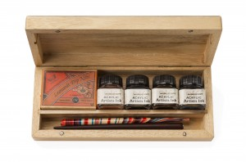

CALLICREATIVE WHITE MARKERS
Do you fancy the very popular blackboard effect / white on black? Then the white markers are the perfect tool for you! On coloured paper in general and also for shading they are ideal! Immediate replace cap after use.
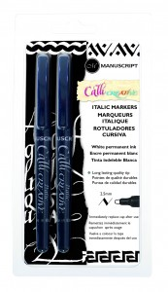
CREATIVE WRITING PRACTICE PAD
This new practice pad is the much welcomed addition to Manuscript’s Creative Calligraphy and Colouring range.
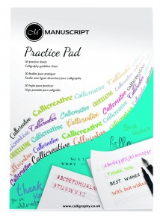
We hope you like what you’ve seen so far…more to come!

