FOR IMMEDIATE RELEASE

Contact:
Annie Breen
Marketing Communications Manager
Brondell Inc.
(888) 542-3355
annie@brondell.com

Brondell Debuts Swash 1400 Advanced Bidet Toilet Seat, A Fresh Approach to Personal Hygiene

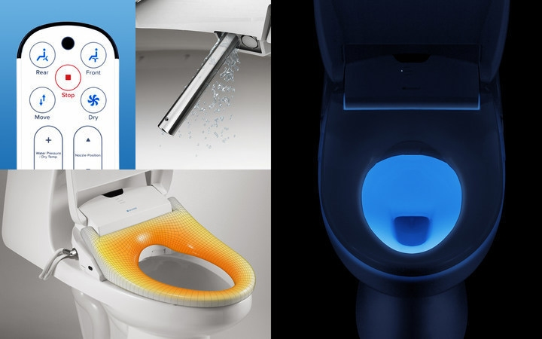

SAN FRANCISCO, Nov. 17, 2016 /PRNewswire/ -- A beloved home fixture throughout Asia and Europe for over 100 years, the bidet toilet seat has finally made a name for itself in the American market. With the advent of smart bathroom technology and recent findings in sanitation studies, the once-foreign method of cleaning one's behind with water (instead of toilet paper) is becoming a common practice in modern American bathrooms.

Brondell, a leading designer and manufacturer of innovative health and wellness products, has announced the debut of the Swash 1400, an intelligent electronic bidet toilet seat that brings the best of technology, personal hygiene, and comfort together in a sleek, luxurious design boasting a hands-free cleaning experience.
"Throughout history, people have used water to clean their bodies. It's much more comfortable and hygienic than either dry, irritating paper, or expensive and environmentally damaging flushable wipes. Our message to North America is a clear and simple one – wash, don't wipe," says Steven Scheer, president of Brondell.

The Swash 1400 offers advanced features that include dual stainless-steel sterilized nozzles, and customizable nozzle positions, water temperatures, water pressures, and spray widths for a fresh, clean wash. The product offers added comfort and convenience with its warm air dryer, deodorizer, heated seat, and a soothing nightlight for those midnight trips to the bathroom. Its new programming offers up to two user settings customized to user preferences, as well as a remote control.
Investing in a traditional bidet comes with a hefty price tag and installation headache; however, the Swash 1400 is an easily installed bidet toilet seat that fits on 98% of commercial toilets at a fraction of the price.

Brondell has built a reputation for innovative, high-quality design with a focus on health and hygiene. The company has demonstrated this commitment through the extensive research in developing the Swash 1400, one of the most advanced, comfortable, and intuitive bidet seats on the market.

The Swash 1400 has just launched on Kickstarter, where the company is hosting an exclusive debut of the product.

About Brondell
Based in San Francisco, California, Brondell is the innovative industry leader in health and wellness products. Brondell currently sells the Swash line of advanced bidet toilet seats, the LumaWarm heated nightlight toilet seat, the Spa suite of entry-level bidet products, the H2O+ line of water filtration systems, and the O2+ line of air purification systems.
Its unique blend of the latest technology and modern design has earned numerous awards. All offerings reflect Brondell's commitment to quality design, with a focus on allowing its customers to create healthy homes with its affordably luxurious products.
Media Contact:
Annie Breen
Manager, PR & Marketing Communications
133912@email4pr.com
415-872-1624

###

