Neolith by TheSize expands its surfacing solutions with new additions to its celebrated collections

Castellón, Spain (2016) – TheSize, manufacturer of sintered compact surface brand Neolith, expands its range of premium surfaces with revolutionary product launches. This year, Neolith’s introductions go well beyond just pattern design – offering new thicknesses, formats and finishes. These imaginative introductions will be revealed at the 2017 Kitchen and Bath Industry Show (KBIS), in Orlando, Florida on January 10 through January 12.
Attendees will have the opportunity to interact with the materials and be able to appreciate the elaborate details in each manufactured design. Inspired by past and present, the new décors are a unification of architectural influences, natural marbles from around the world and collaborative workings of in-house designers at TheSize.
MAN MADE NATURAL DÉCOR
Blanco Carrara (Classtone Collection):
Figure 1 Blanco Carrara BC01 and BC02
Inspired by real Carrara marbles from Italy, Blanco Carrara is the result of a meticulous selection process. TheSize in-house designers collated dozens of natural Carrara marbles found in Italy and from each one, selected the exact quality and characteristic to be replicated in the Neolith slab. With this custom approach, the final product is a truly unique entity, comprising natural aesthetic elements exclusive to TheSize – there is literally no natural or manufactured stone like it.
To realistically portray the likeness of natural marbles and their unpredictability, two versions of Blanco Carrara have been created – one a more subtle portrayal of the veining and the other, a prominent, high-contrast version. Blanco Carrara is available in two thicknesses, 6mm and 12mm, and in two finishes, Polished and the new introduction, Antique. Blanco Carrara is especially suited for floors, walls, bathroom and kitchen worktops and furniture.

Nero Marquina (Classtone Collection):
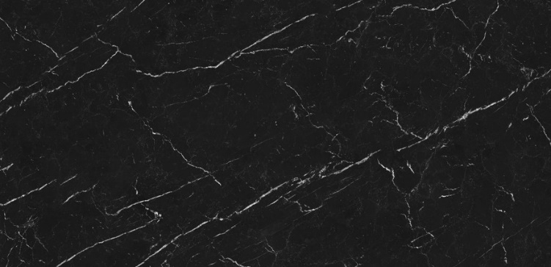
Figure 2 Nero Marquina
Neolith’s answer to a timeless monochromatic trend that transcends interior design, fashion and architecture, this décor is a vital part of these introductions. Inspired by marble from Spain, Nero Marquina is a testament to the technical expertise present at TheSize. To achieve bright white veining on a pure black backdrop is a task challenging enough on paper, but for a slab, a new technical avenue is entered. For this, TheSize developed an exclusive technique to achieve the stark contrast and distinct fine lines. Available in Polished and Silk finishes and in 6mm and 12mm thicknesses, Nero Marquina is ideal for floors, walls, bathroom and kitchen worktops, as well as furniture.
Taj Mahal (Classtone Collection):
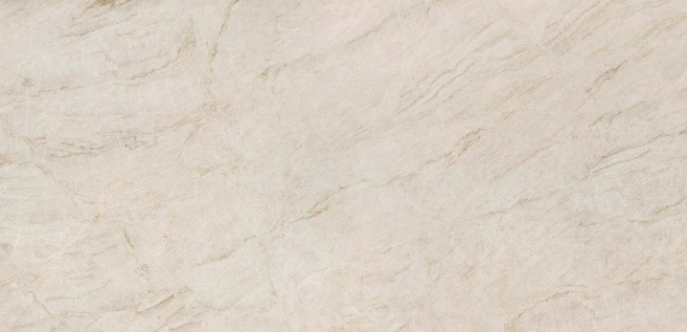
Figure 3 Taj Mahal
A traditional representation of the multidimensional Indian Quatzite, Taj Mahal revels in rich, in depth and luxurious attention to detail. With light cream as its backdrop, together with a combination of clear flakes to emulate the natural crystallization of multiple pink quartz layers, it embodies natural quartzite flawlessly. To enhance the design further, the fine integration of subtle brown and grey veins add just enough diversity, while still keeping it in the neutral color family. A material in heavy demand in the USA and UK, the Taj Mahal slabs are currently exclusively available in the Polished finish and 12mm thickness, for a sleek and minimal take on kitchen and bathroom worktops.
Zaha Stone (Fusion Collection):
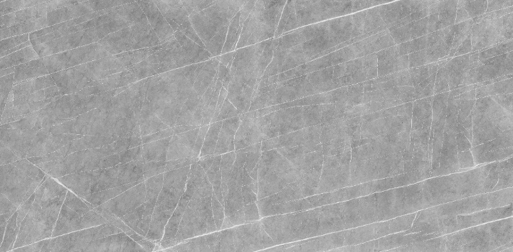
Figure 4 Zaha Stone
TheSize takes you on a trip to Iran with this contemporary twist on Iranian Gray Stone. The Neolith design incorporates a richer, industrial grey tone, with white veins etched onto the backdrop in contradicting directions. This slab pays tribute to the recently deceased and incredibly talented Zaha Hadid, a true inspiration to the architectural community. This slab is the most daring new model created this year and is a nod of recognition from TheSize to the legacy left behind by Hadid. Available in 6mm and 12mm and in Antique finish, the Persian inspired stone is the statement piece of these new introductions.
Concrete Taupe (Fusion Collection):
Figure 5 Concrete Taupe
Following suit from one of the most popular décors from the 2015 Neolith launches, Concrete Taupe differentiates itself from its predecessor Beton with an all over brown wash of color and warmer tone. Appealing to industrial design trends, the slab tells a story of time with a well-loved finish. The décor suggests that a natural rusting has occurred but with the addition of micro flakes to add the slightest sparkle, TheSize updated, modernized and created another facet to the slab. Available in 6mm and 12mm in Antique finish, Concrete Taupe is a neutral décor ideal for a multitude of applications ranging from interior, exterior cladding and furniture.

Aspen Grey (Fusion Collection):
Figure 6 Aspen Grey
Following the launch of its first full body décor, Pierre Bleue, TheSize launches yet another full body – a dark grey matte inspired by natural Aspen stone. With countless micro elements scattered throughout, the slab offers movement with a sense of ornateness and character. Aligned with the same Neolith Digital Design (NDD) technology used to develop the Pierre Bleue décor, Aspen Grey’s color is present through the entirety of the slab. Available in 6mm and 12mm in soft touch Silk, it presents itself as the ideal slab for creating the illusion of texture in interior and exterior cladding, flooring, kitchen and bathroom worktops, and furniture applications.
AND FOR THE BIG FINISH:
Antique
True to its name, Antique is a finish that has the ability to create the impression of time. Matte and soft to the touch, the finish allows for the best of both worlds, where the visuals of a worn out texture are present, without compromising the quality of the slab. Each finish available in Antique is granted a new charm that possess its own character. When applied to a décor, the finish conveys a sense of realism to the slabs by adding subtle waves and the illusion of an aged material.
NanoTech Polished
Second in a series, NanoTech Polished is the successor of the original Décor Polished – a high gloss finish achieved by layering glass on top of the slab. NanoTech Polished, however, manages to achieve the same glossy finish achieved in Décor Polished, without the need for the additional glass layer. Instead of applying the cover, the slab is directly polished once it comes out of the kiln and by using a special raw material during the sinterization process and a studied polishing technique, a perfectly flat reflection is achieved.
STIRRING UP THE INDUSTRY:
Forever innovating and disrupting the industry, 2017 will see TheSize become the first manufacturer to produce a 20mm thickness with its proprietary sintering technology. It is cementing TheSize as a market leader and the only player in the game to offer such a wide range of possibilities; from 3mm to 20mm, and exterior cladding to worktops and furniture cladding. The 20mm thickness will be available with a select few décors initially; Basalt Black Satin; Arctic White Silk; Cement Satin; Beton Silk; and Pierre Bleue Silk.
Alongside this new thickness, the 3mm slab is now available in the award winning Calacatta; Estatuario; Pulpis; Strata Argentum; Calacatta Gold; Pierre Bleue; Beton; and Iron Frost. With these additions to the 3mm thickness production line, customers can now specify favorite décors from the Neolith range for furniture cladding or interior walls, further breaking down boundaries of interior design at TheSize.
With the new introductions, Neolith now offers over 56 different designs across its seven collections that are available in multiple finishes and thicknesses providing specifiers with a broader range of design possibilities.
Neolith products are available in the U.S. and worldwide through a large network of distributors. For a location near you or to learn more, visit Neolith at www.neolith.com.
About TheSize Surfaces SL
TheSize founded in 2009 with the objective of expanding and improving the thriving ceramic sector prevalent in the company’s headquarters, Castellón, Spain. The company launched all-natural sintered compact surface Neolith in 2010, a durable material created through a high-temperature, high-pressure process called sinterization. For more information on TheSize and its products, please visit www.thesize.es

For more information, contact:
Ashley Eisner/Jacqueline Charles
G&S Business Communications
Tel: 212-697-2600
AEisner@gscommunications.com /JCharles@gscommunications.com

