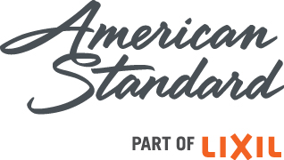

For more information:
Nora DePalma, O’Reilly DePalma
For LIXIL Water Technology Americas
American Standard, DXV
(770) 772-4726
nora.depalma@oreilly-depalma.com
FOR IMMEDIATE RELEASE
New ActiClean Toilet from American Standard
Stays Sparkling Clean with the Press of a Button

Self-Cleaning Toilet Delivers Effortless Maintenance and
Unmatched Performance at an Affordable Price

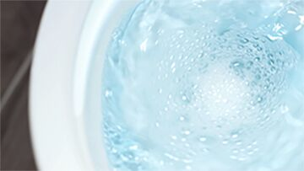
PISCATAWAY, N.J. (September 22, 2016) ― Keeping a sparkling clean bathroom just got easier with the American Standard ActiClean self-cleaning toilet. The new ActiClean system is the toilet that cleans itself, combining the power of revolutionary VorMax flushing technology — which delivers the cleanest flush ever engineered — with a fully integrated self-cleaning system. Simply press a button, walk away, and let the toilet do the rest – it’s that easy.
ActiClean eliminates the need for after-market add-on cleaning solutions that are unsightly, ineffective and may even damage toilets. No more in-the-bowl or in-the-tank cleaning solutions that may not work effectively with high efficiency, low consumption toilets. This pioneering ActiClean toilet provides the luxury of a toilet that cleans itself – featuring a simplified, user-selected activation system – at a price point favorable to a broad range of homeowners.
The new ActiClean self-cleaning toilet from American Standard combines a freshly scented cleaning solution with the powerful VorMax jetted flushing technology to completely scour the bowl from top to bottom.
- more -

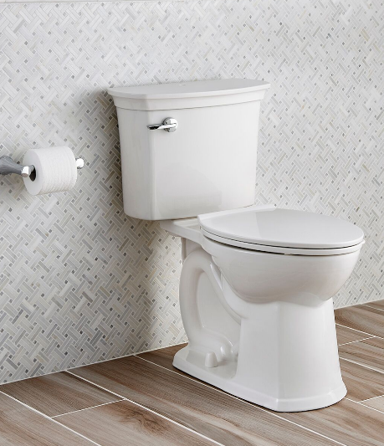
“The innovative ActiClean toilet was created based on consumer research. We found that consumers are excited about the idea of owning a self-cleaning toilet,” said Maha El Kharbotly, chief marketing officer for LIXIL Water Technology Americas. “Our incredible product, engineering and design teams rose to the challenge, taking the groundbreaking VorMax flushing technology a step further by adding a cleaning component, and creating a self-cleaning system that is simple to use and maintain.”
Classic design lines with graceful detailing are highlighted in the new ActiClean self-cleaning toilet from American Standard, with all cleaning components discreetly hidden in the tank top for easy access.

The ActiClean Self-Cleaning System
A convenient flip-up door on the tank top houses the control panel for the cleaning system, which is activated at the user’s choice. For homes with small children, the cleaning function can be locked and the cleaning cycle can even be canceled mid-cycle, if needed.

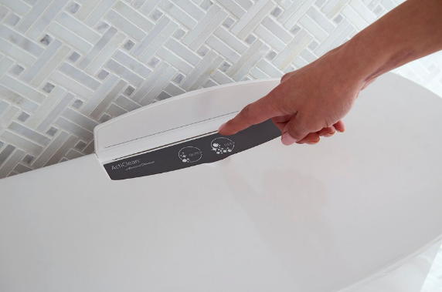
Here’s how the ActiClean system works:
- The user presses the button for the preferred cleaning cycle: a Quick Clean that takes one minute; or a Deep Clean that offers an extended, 10-minute cleaning cycle.
- Cleaning solution travels through the designated channel in the tank and is mixed with water.
At the press of a button, the new ActiClean self-cleaning toilet from American Standard scours the bowl from top to bottom with cleaning fluid, using the power of the brand-exclusive VorMax flush to deliver a sparkling clean toilet.
- The cleaner is released into the bowl, combined with the powerful VorMax jetted force, which allows the cleaner to completely scour the bowl from top to bottom.
- The cleaner soaks in the bowl for the chosen amount of time. Its fresh fragrance and foaming bubbles indicate it’s hard at work.
- When the soaking time has ended, the system will automatically siphon the cleaning agent and rinse the bowl with clear water.

- more -

To help the ActiClean stay even cleaner, the bowl features a sleek, CleanCurve Rim that omits the rim cavity and holes inside the bowl where dirt and buildup can get trapped and hide. The toilet tank and bowl feature EverClean, the brand-exclusive permanent finish that inhibits the growth of stain and odor-causing bacteria, mold and mildew on the surface. The smooth, mirror-like EverClean finish repels dirt, helping the toilet stay cleaner, longer.
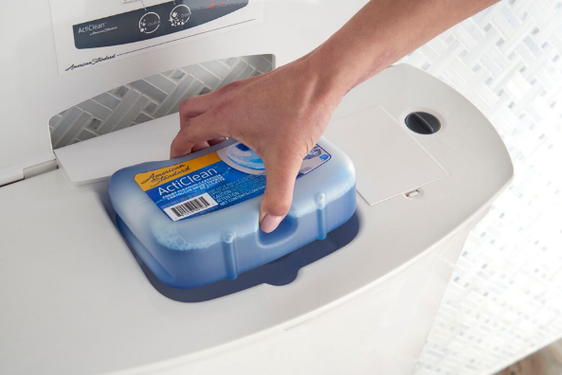
Simple Maintenance and Operation
The cleaning solution cartridge will last up to nine weeks, based on two weekly cleanings: one Quick Clean and one Deep Clean. The replaceable cleaning cartridge is easy to access, located in a compartment discreetly positioned in the toilet tank top.
The cleaning cartridge for the new ActiClean self-cleaning toilet from American Standard is discreetly hidden in the tank lid for convenience and easy access.

The cleaning system is powered by ordinary alkaline batteries. They are installed in an easy-to-reach place in the toilet tank lid and can be popped out by hand – no tools are required to access them. Four AA batteries will last for approximately one year with normal use. The initial cleaning solution cartridge and four AA alkaline batteries are included with the purchase of the ActiClean toilet.

The cleaning system runs independently from the normal toilet flushing operation, meaning the toilet will always flush, even if the cleaning cartridge or batteries have run out.

The Cleanest Flush Ever Engineered
The VorMax flushing technology, introduced in 2014, reinvented the toilet-cleaning experience by helping to eliminate skid marks, splatter and clingy dirt, which are common problems with toilet usage. In fact, the VorMax flushing system has been independently verified to clean the bowl two times better than conventional toilets*. The high-efficiency VorMax flush in the ActiClean toilet uses a single powerful jet of only 1.28 gallons of water to scrub the entire bowl with each flush. That translates into less elbow grease and lower cleaning supply costs.
- more -

The ActiClean toilet is capable of successfully removing 1,000 grams (2.2 pounds) of waste with this water-saving 1.28 gallons per flush (gpf). This achieves the highest score on the Maximum Performance (MaP) test, an independent report of toilet performance. The ActiClean self-cleaning toilet has earned WaterSense-certification from the U.S. Environmental Protection Agency (EPA) for providing high performance while using 20 percent less water than traditional 1.6 gpf toilets.
High Style, High Comfort
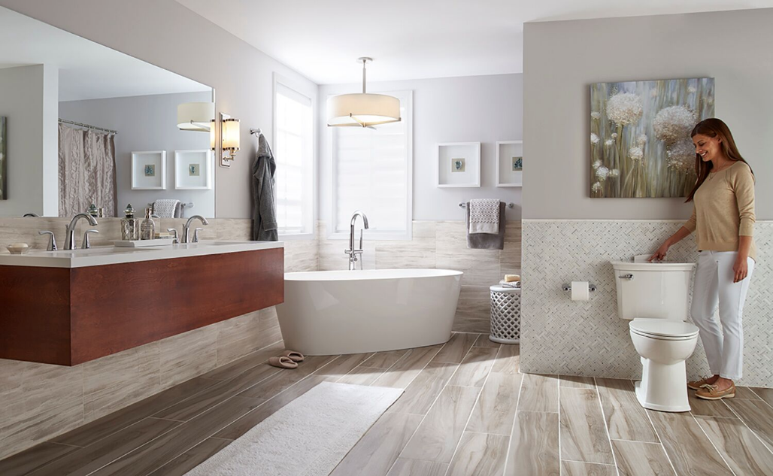
Showcasing stylish design with classic detailing, the presentation of the two-piece ActiClean toilet is streamlined, with cleaning system components tucked away inside the tank top for a neat, attractive appearance. The toilet’s flat top provides convenient room for favorite bath decor items. For personalized comfort, the ActiClean bowl is available in an elongated, Right Height (16-½ inches) configuration that is ADA-compliant.
To further accentuate the fixture’s sleek good looks, the slow-close ActiClean seat showcases a contemporary design with no overhang on the front and sides of the bowl, creating a seamless look when closed. The slow-close feature prevents the noise, and pinched fingers, of sudden toilet-seat slamming. Anti-slip bumpers lock the seat in place, so that it does not shift when in use.
The stylish, new ActiClean self-cleaning toilet from American Standard makes it simple to keep your toilet sparkling without gloves or a brush, all at a surprisingly affordable price tag. The ActiClean toilet coordinates with the American Standard Coastal-Serin freestanding bathtub, Studio bathroom sinks, Fluent bath faucets and Contemporary round floor-mount tub filler.
- more -

For a thorough cleaning of both the toilet seat and top of bowl, a release button permits the quick and easy removal of the entire seat. There is also a sanitary tab on the seat that provides for easy lifting, while allowing the user to avoid touching the toilet.

The versatile design of the ActiClean toilet coordinates with numerous American Standard fixture and faucet collections. Favorite pairings include the Coastal-Serin freestanding bathtub with Contemporary round floor mount tub filler, plus the Studio undercounter bathroom sink with Fluent widespread faucet, for a complete bathroom suite.
To further enhance the easy maintenance of the new American Standard ActiClean self-cleaning toilet, it includes a release button for quick and convenient removal of the seat for more thorough cleaning.

The ActiClean toilet, with a 12-inch rough-in configuration, includes an EZ-Install kit designed to make installation speedy and trouble-free. This high efficiency toilet is protected by a limited lifetime warranty on chinaware, a ten-year limited warranty on mechanical parts, and a one-year limited warranty on both the electronics and the seat.

The list price for an ActiClean self-cleaning toilet is $695. Each toilet comes packed with one cleaning cartridge and a set of four AA batteries in the carton, along with the toilet tank, bowl and seat. Replacement American Standard cleaning cartridges have a list price of $14.99. The ActiClean toilet is available at Lowe’s and in select kitchen and bath showrooms nationwide.

For more information on the ActiClean toilet cleaning technology from American Standard, visit www.americanstandard.com or call (800) 442-1902.

*Source: IAPMO R&T Labs Test Report No. 109-141486-002, comparing VorMax against conventional under-the-rim-water-dispersal toilets from major retailers.

- more -

ABOUT AMERICAN STANDARD BRANDS
American Standard Brands make life healthier, safer and more beautiful at home, at work, in the community and throughout the world. Offering total project solutions for residential and commercial customers around the world with respected brands such as American Standard®, DXV®, Safety Tubs®, Crane Plumbing®, Eljer®, Fiat® and Decorative Panels International®. American Standard Brands is owned by LIXIL Corporation (TSE Code 5938), and is part of LIXIL Water Technology business, which operates across 150 countries. The LIXIL Water Technology brands include: LIXIL, INAX, GROHE, American Standard, and JAXSON. Learn more at www.americanstandard.com, or follow us at twitter.com/AmStandard, https://www.facebook.com/AmericanStandardPlumbing.

CleanCurve Rim®, EverClean®, Right Height®, Serin® and VorMax® are registered trademarks of American Standard Brands.

ActiClean™ and Coastal™ are trademarks of American Standard Brands.

WaterSense® is a registered trademark of the U.S. Environmental Protection Agency (EPA).

MaP report conducted by Veritec Consulting Inc. and Koeller and Company.

###

