The new hue of Noble Concrete Grey … inspired by concrete
Unimaginable solutions then, the core of modern interiors today. The design of pure concrete is a timeless style, as the Salone del Mobile in Milan has shown. Its elements combined with wood, glass or white backgrounds bring to households the industrial atmosphere that is becoming more popular. That's why the company Technistone, the major global manufacturer of engineered stone, introduced the new shade Noble Concrete Grey in the appearance of raw concrete.
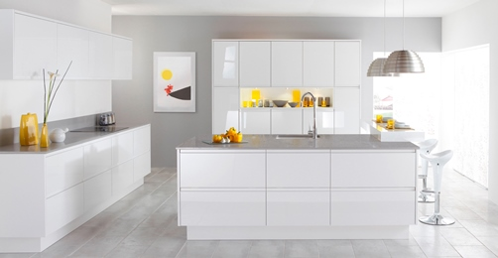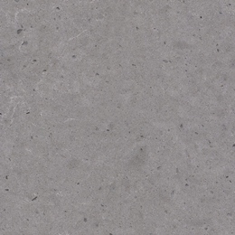
The design of concrete screed gives a minimalist and balanced appearance. "It is a very timeless color which is not subject to fashion trends in design. It also primary brings to the interior rudeness, naturalness and originality. At first glance, the interior may appear unfinished, but its great potential is in the possibility to match that kind of material with glass, wood or metal elements," says interior designer Hana Michálková.
The everlasting beauty
Kitchens, bathrooms or bedrooms. Industrial style can surround us anywhere. Especially in Europe, the trend of concrete, steel and other materials has been becoming popular. But also the main emphasis is on keeping the luxury of pure performance and best utility properties. That's why Technistone® introduced a new shade which imitates the appearance of concrete - Concrete Grey Noble. "Concrete design is promoted in interiors worldwide. I am very pleased that we have included this trend in our assortment. I suggest the Quartz stone shade Noble Concrete Grey to use primarily in the kitchen, where you most appreciate its more superior utility properties then the real concrete has," says Dušan Hrneček, the product manager of Technistone.
New engineered stone Noble Concrete Grey by Technistone excels with its structure that imitates the form of raw concrete, however the compactness and strength of the material is much higher. Quartz stone Noble Concrete Grey is made up of more than 85 % natural ingredients. The visual effect of textured, brushed or glazed concrete is made by special surfacing – Matt that subtly reveals the texture of used grain in dim appearance and by Ardesia whose one-way texture found inspiration in natural slate.
Unlike real concrete, the Noble Concrete Grey is compact material without visible porosity, eliminating the practical drawbacks of concrete products. Quartz stone has a lower water absorption, higher strength, and higher resistance to staining and the effects of detergents commonly used in households. The indisputable advantage of Technistone is also the possibility of installing thinner and therefore lighter boards as well.
Engineered stone Noble Concrete Grey offers a wide range of applications in the interior, especially in the form of kitchen countertops or cladding.

Find more information on www.technistone.com.

Technistone introduction
Technistone, a.s. is a leading producer of engineered stone from Europe with more than 20 years of manufacturing history. Headquartered in the Czech Republic, the heart of Europe, production began in 1992 with the original Bretonstone technology. In the same year the legendary Starlight Collection was invented and the world standard of premium quartz surfaces was set. Since 1992 Technistone has produced 6.200.723 sqm. of quartz (about 50.000 sqm. every month). Technistone products are distributed in 70 countries on 5 continents. In 2015 Technistone produced more than 400 variants of the product.

Architects and designers consider Technistone materials as one of their favourites thanks to its unique characteristics, interior creativity potential and trustworthy mechanical properties. Technistone is used for kitchen countertops, vanity units, bars, tiles, stairs, etc. Technistone products also can be found throughout a variety of commercial and residential facilities around the world. The Lusail Multipurpose Hall in Qatar, John F. Kennedy International Airport in the USA, Design Studio Porsche in Germany, Heathrow Airport, Terminal 5 in the UK, Hotel Hilton Lodz in Poland, Shopping Mall Milenium in China, Shopping mall in Tunisia, just to name a few of the impressive projects proudly displaying Technistone surfaces.

Technistone is a member of the World-Wide Agglomerated Stone Manufacturers Association, the National Kitchen & Bath Association and U.S. Green Building Council. Technistone is certified by the independent and world recognized SCS for the content of recycled material in its products. The product is in compliance with the 51 NSF/ANSI Standard. Material is suitable for food contact and does not contain any volatile compounds. Certificate EN ISO 9001.
Explore TS Color Range, try new Technistone visualizer, e-brochures and find more information on the website www.technistone.com.

