**Set to debut at KBIS, TheSize expands its range of premium Neolith sintered compact surface solutions with a new collection and new designs**

**Castellón, SPAIN (November 2015)** – TheSize, designer and manufacturer of the Neolith brand, expands its range of premium sintered compact surface solutions for countertops, flooring, walls and more. Debuting at the 2016 Kitchen and Bath Industry Show (KBIS) in Las Vegas are several products, including the new Steel Collection; six different designs; and a new full body slab.

TheSize now offers over 50 different designs across Neolith’s seven collections – available in Satin, Polished, Silk or Riverwashed finishes and 3, 6 or 12 mm thicknesses – providing designers, architects and specifiers with even more choice and a broader range of design possibilities.

***A BRAND NEW COLLECTION***

With the introduction of the Neolith Steel Collection, TheSize is aligning itself with the latest market trends for industrial-inspired interiors. The Steel Collection is the perfect alternative to stainless steel, combining a metallic feel throughout the slab with the high-tech properties of sintered compact surfacing.

Exclusive to the all-new Steel Collection is the Steel Marengo design, offing a dark grey metallic and reflective tone, designed for 12 mm kitchen countertop applications.

[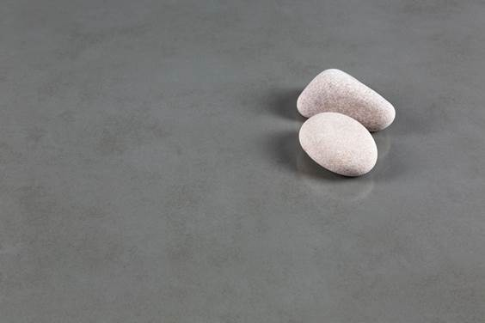](http://www.neolith.com/)

*Neolith Steel Marengo (Steel Collection)*

***NEW DESIGNS***

***Classtone Collection: Calacatta Gold and Strata Argentum***

Following the success of Calacatta, winner of the Red Dot Award: Product Design 2015 and Muuuz International Awards 2015 (MIAW), is the introduction of Neolith Calacatta Gold, a natural marble aesthetic that meets the durability of sintered compact surfacing. Calacatta Gold incorporates intricate, authentic gold veining in book- or end-matched effects over a bright white backdrop. It is available in Silk and Polished finishes.

Inspired by Silver Travertine marble is Neolith’s new Strata Argentum, defined by its delicate, horizontal-veined white and silver lines to mimic the beauty of the Italian marble in a durable, low maintenance sintered compact surface. Available in a Riverwashed finish, Strata Argentum replicates the original texture of natural stone at its rawest state.

Both Calacatta Gold and Strata Argentum are part of the Classtone Collection, a range of striking sophisticated marble designs available in 6 and 12 mm thicknesses, especially suited for countertops, flooring and cladding.

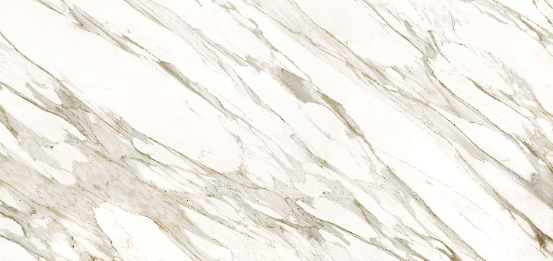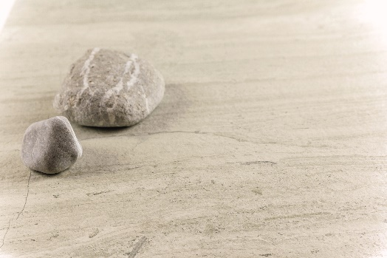

*Neolith Calacatta Gold / Neolith Strata Argentum*

***Timber Collection:******La Bohème***

New to the Neolith Timber Collection, TheSize introduces its first wood finish, La Bohème. La Bohème is offered in two versions, La Bohème B01 and La Bohème B02, both ideal for countertop applications and kitchen islands. Inspired by the trunk of the Lebanese Cedar tree, this new design stands out from the collection with its bold grain and raw wooden color. When combined with marble, stone or steel, it gives a modern and warm look with a touch of romanticism.

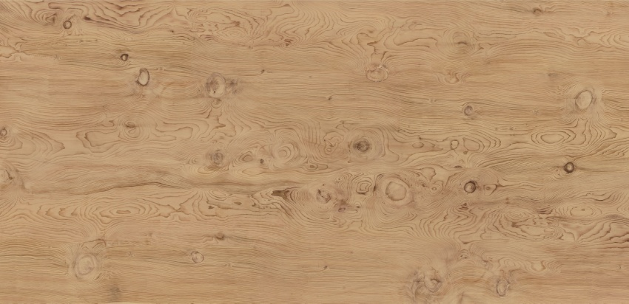

*Neolith La Bohème (Timber Collection)*

|  |
| --- |
| ***Iron Collection: Iron Frost***  Iron Frost, now available through the Neolith Iron Collection, is a neutral and minimalist design that is distinguished by its delicate notes of metallic sheen and white background with light grey shades. With this new model, the Iron Collection now offers 7 different modern and eye-catching designs in 3, 6, and 12 mm thicknesses, and a Satin finish. |

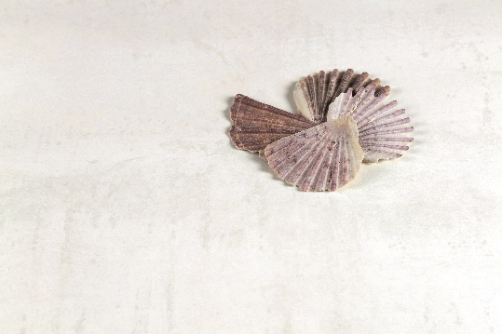

*Neolith Iron Frost (Iron Collection)*

***PIERRE BLEUE: NEWEST FULL BODY DÉCOR***

Pierre Bleue, new to the Neolith Fusion Collection, is a reinterpretation of a Neolith classic: Belgian Blue. Inspired by the natural stone known as “le Petit Granit,” this design employs the latest techniques in full body slabs and NDD (Neolith Digital Design) technologies. Integrating numerous fossils and rock elements through the entire grey-blue body, Pierre Bleue stands out for its high-degree of definition and realism. Pierre Bleue is available in 6 and 12 mm thicknesses.

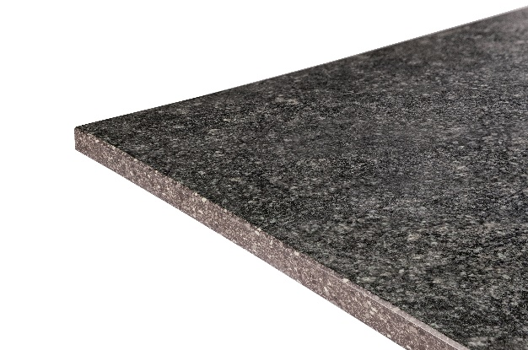

*Neolith Pierre Bleue (Fusion Collection)*

***NEW TREATMENT: NATURAL HONED***

The Natural Honed effect is achieved by applying a special treatment to the Neolith surface that results in a matte finish, typical of natural stones.

Applying Natural Honedto a Neolith Satin finish design enhances the softness of the surface. When applied to a Silk finish design, the effect decreases light that reflects off the surface, ensuring a soft and silky aesthetic.

The Natural Honed effect reinforces TheSize’s dedication to providing surfacing solutions that meet the highest expectations of both clients and industry professionals.

For more information on the TheSize’s Neolith brand and all new products, visit [www.neolith.com](http://www.neolith.com).

**About TheSize Surfaces SL**TheSize founded in 2009 with the objective of expanding and improving the thriving ceramic sector prevalent in the company’s headquarters, Castellón, Spain. The company launched all-natural sintered compact surface Neolith in 2010, a durable material created through a high-temperature, high-pressure process called sinterization. For more information on TheSize and its products, please visit [www.thesize.es](http://www.thesize.es/).

**For more information, contact:**Ashley Eisner/Jacqueline Charles

G&S Business Communications

Tel: 212-697-2600

[AEisner@gscommunctions.com](mailto:AEisner@gscommunctions.com) /[JCharles@GScommunications.com](mailto:JCharles@GScommunications.com)