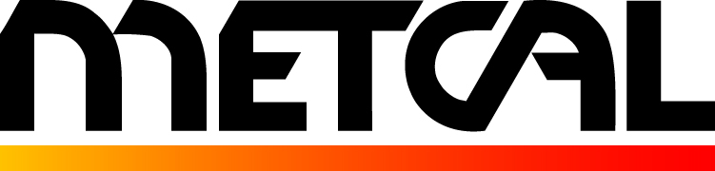
10800 Valley View St.
FOR IMMEDIATE RELEASE Cypress, CA 90630
Contact: Jerry Simmons Phone: 714-799-9910
E-mail: jsimmons@metcal.com
Web Site: www.metcal.com

Metcal to Launch Connection Validation – the Latest Innovation in Hand Soldering – at APEX

CYPRESS, CA ― January 2017 ― Metcal today announced plans to exhibit at the 2017 IPC APEX EXPO, scheduled to take place Feb. 14-16, 2017 at the San Diego Convention Center in Calif. The company will showcase its hand soldering systems and tools, the Scarab Site Cleaning System, Scorpion Rework System, and fume extraction systems in Booth #3035.

Metcal will introduce Connection Validation, its latest patented technological innovation that promises to change hand soldering! Currently, the industry standard relies on a visual inspection of the solder joint. With Connection Validation, Metcal has developed a better way. Built on the company’s SmartHeat™ technology, used in all Metcal soldering systems, Connection Validation evaluates the quality of the solder joint by calculating the intermetallic compound formation and provides closed-loop feedback to the operator, mitigating risk in the process. Demo units will be available at the show for hands on demonstrations.

Metcal also will introduce and demonstrate the new High Thermal Demand (HTD) upgrade kit for its line of higher-end power supplies. The High Thermal Demand product kit maximizes thermal efficiency by delivering more thermal energy to the solder joint in less time, enabling more soldering applications and increasing line throughput.

Also at its booth, Metcal will have the recently released Solder Wire Feeder and the Scarab Site Cleaning Systems. The Solder Wire Feeder pairs with the MX series Soldering & Rework Systems, speeding up the soldering process and increasing line efficiency by placing more control and convenience in the hands of the operator. The Scarab Site Cleaning System ensures accurate and repeatable cleaning of the component pad in one contactless user-friendly system. The system allows the user to add site-cleaning capability to their operation without the investment of replacing their current component rework system.
For more information about any of Metcal’s bench tool solutions, visit www.metcal.com.

###
About Metcal

Since 1982, Metcal has been a recognized worldwide leader in the electronics assembly marketplace. Metcal has an industry-leading position providing advanced technology products in conduction soldering, rework/repair, fume extraction and fluid dispensing arenas. Metcal product line includes hand soldering and desoldering, convection rework, advanced package rework, fume extraction and fluid dispensing products. Metcal products continue to set the standard for performance, reliability, flexibility and cost-effective performance and are available from authorized distributors in North America and around the world. For more information, visit www.metcal.com.

