
10800 Valley View St.
FOR IMMEDIATE RELEASE Cypress, CA 90630
Contact: Jerry Simmons Phone: 714-799-9910
E-mail: jsimmons@metcal.com
Web Site: www.metcal.com

Metcal Announces Global Launch of Solder Wire Feeder System

CYPRESS, CA ― December 2016 ― Metcal today announced the global launch of the Solder Wire Feeder System. The feeder system speeds up the soldering process and increases efficiency by adding control and convenience to the line.

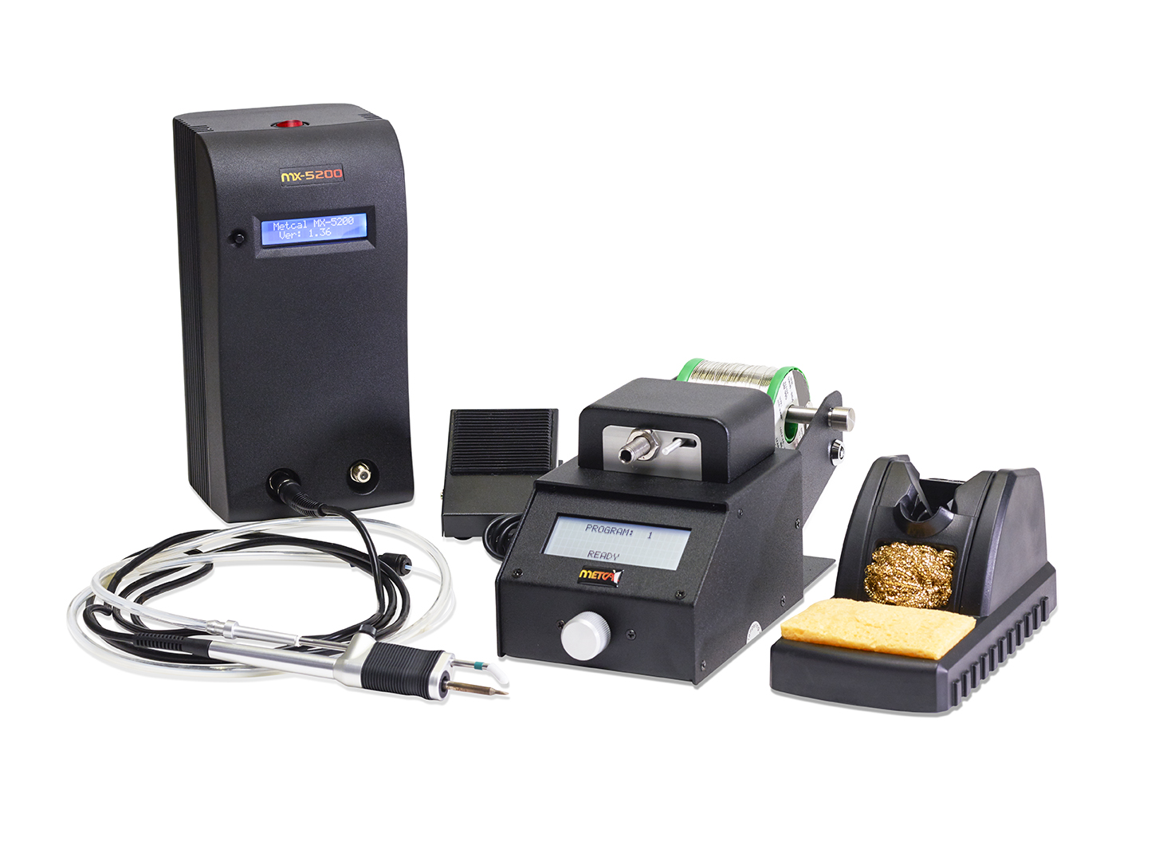
The Solder Wire Feeder pairs with Metcal’s SmartHeat® MX-5200 or MX-500 Soldering and Rework Systems. The digital controls, along with the system’s high performance and ability to handle multiple diameters, provides repeatability and functionality.

The digital controls feature multiple modes of operation, including forward feed, retraction, delay and speed, all programmable parameters in either the automatic, forward, or the backward mode of operation. Additionally, the large LCD screen displays program parameters and a cycle counter with the selectable unit of measure, millimetres or inches.
Solder Wire Feeder

With internal program storage, the Solder Wire Feeder stores 30 programs, allowing the operator to select the right program for each application. Password protection prevents unintended changes to stored programs, and multiple solder diameters make the system compatible with solder diameters from 0.3mm to 1.27mm.

For more information about any of Metcal’s bench tool solutions, visit www.metcal.com.

###
About Metcal

Since 1982, Metcal has been a recognized worldwide leader in the electronics assembly marketplace. Metcal has an industry-leading position providing advanced technology products in conduction soldering, rework/repair, fume extraction and fluid dispensing arenas. Metcal product line includes hand soldering and desoldering, convection rework, advanced package rework, fume extraction and fluid dispensing products. Metcal products continue to set the standard for performance, reliability, flexibility and cost-effective performance and are available from authorized distributors in North America and around the world. For more information, visit www.metcal.com.

