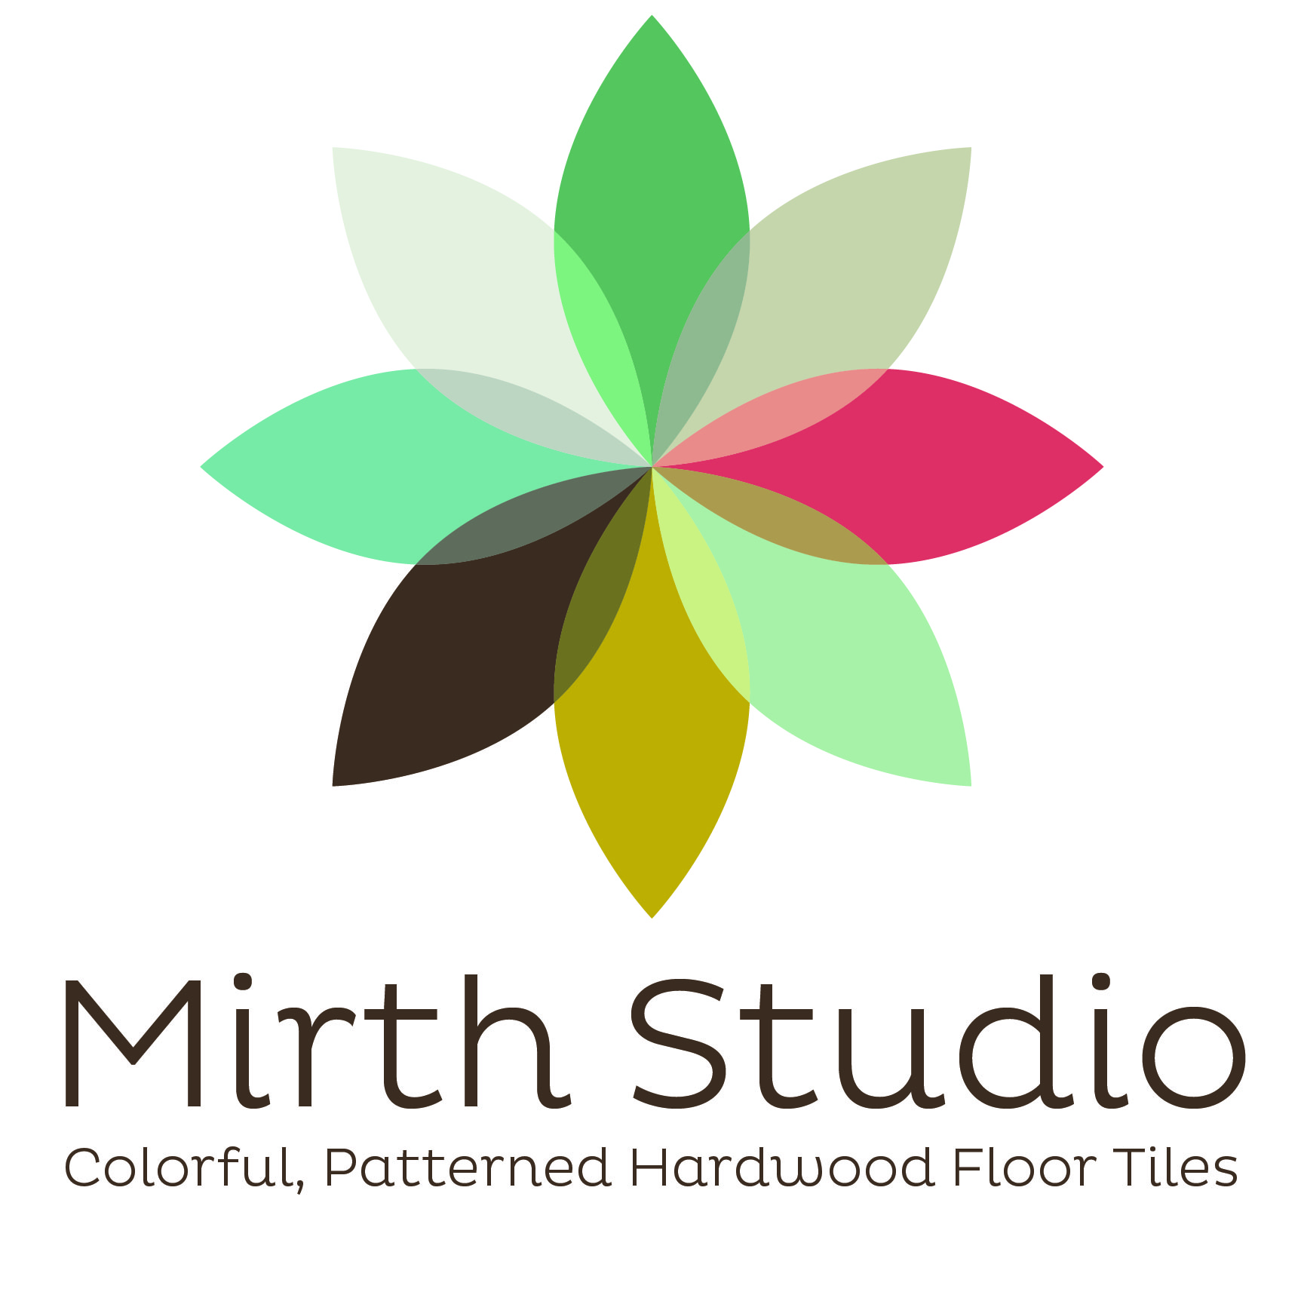
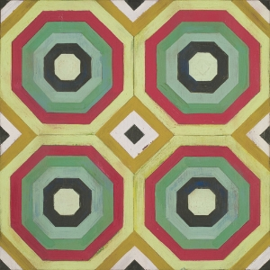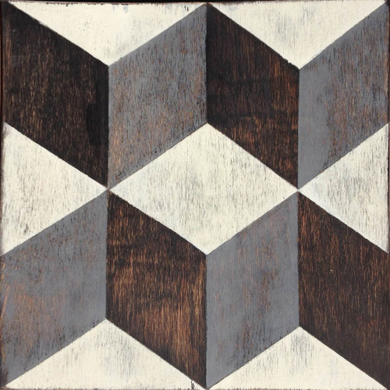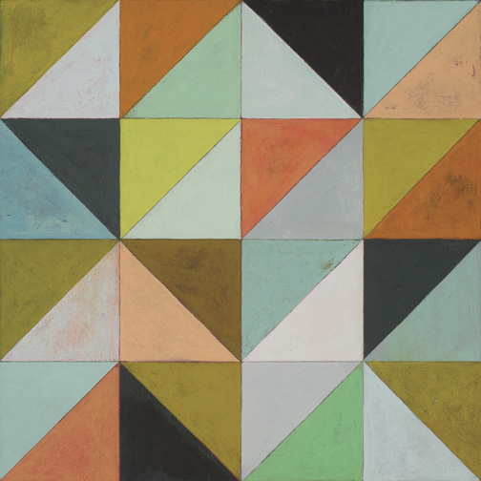

MIRTH STUDIO TO SHOWCASE INNOVATIVE
NEW FLOORING PRODUCTS AT
ICFF
Booth 0987

For Immediate Release:
MIRTH STUDIO TO BE AN EXHIBITOR AT ICFF May 14-17, 2016 Javitz Center, NYC

Mirth Studio of Charleston SC will exhibit its revolutionary engineered wood floor tiles at the ICFF in NYC.

Founded by well-known designer and artist Sally Bennett, Mirth Studio pioneered the concept of colored wood floor tiles that look hand-painted. Using state of the art technology, Mirth Studio is now the only company in the world offering this exceptional, distinctive product. Mirth Studio sells the tiles through its website: www.mirthstudio.com as well as through retailers across the US.

Sally Bennett will be on hand at the Architectural Digest show to present her latest designs for tiles as well as a new line of pattern stair tread risers and Floor and risers decals.

“Exhibiting at ICFF is a fantastic way to introduce Mirth Tiles to the greater design and architecture community. Because we are able to produce custom designs with short lead times and do not require large minimum orders, our tiles are a perfect solution for commercial projects. We hope to get our products in the hands of specifiers by introducing them at ICFF.” Bennett said

About Mirth Studio:
Mirth Studio is a building supplies company specializing in colorful patterned flooring products. Founded in 2013 by artist Sally Bennett, Mirth Studio came about when Bennett was renovating her home in Charleston, SC but was dissatisfied with the available options for floors and other wooden finished surfaces. She invented a new product to be used in her house: engineered wood tiles that are digitally printed with her own designs.
The designs are inspired by patterns and colors in a variety of sources, everything from ceramic Moroccan tiles to wallpaper from the ‘50s and ‘60s.
Mirth Studio Tiles now come in a dazzling array of patterns and colors and can be customized on demand by the designer or homeowner. They’re made of ½” engineered hardwood which won’t warp like ordinary wood floors. Extremely durable, the tiles come pre-finished with a no-VOC UV coating that will last for years, in fact they come with a 15 year warranty for residential use and a 5 year commercial warranty. The tiles use much less hardwood than ordinary plank flooring – only a thin strip on top and bottom – and contain no formaldehyde or other toxic preservatives. Moreover, 100% of the timber used to make Mirth Studio tiles is harvested from plantation-grown trees.

Press:
Mirth Studio has been featured in the following magazines: House Beautiful, Interior Design, Southern Living, Charleston Magazine, Traditional Home, Garden and Gun where we were named as a finalist in the Best of The South Awards. It has also been included in numerous blogs including Apartment Therapy, Cococozy, Domain and many others. Mirth Studio was also featured on The Today Show and NBC’s Open House.

