Media Contact:

Kristin Bradley / Coyne PR

973-588-2295

kbradley@coynepr.com
KaZAM Interbike Introductions

Overview:
Kent International, one of the largest bicycle companies in the U.S., has become a part owner of KaZAM, an industry leader in the balance bike category.

With the unique award winning design of KaZAM balance bikes, kids can skip training wheels, as the bikes provide the opportunity for kids to first learn balance, then gradually pick up the pace until they are able to coast and can make a seamless transition onto a traditional, pedaled bike.

The company is introducing two new balance bikes at Interbike (Booth # 5188) that will be available this fall.

Product Descriptions:
20” Swoop Balance Bike
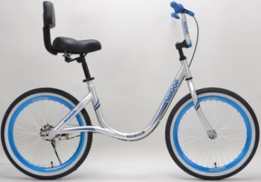
- KaZAM’s Swoop Balance Bike is ideal for taller children who haven’t yet mastered bike riding. With a step-through frame design, it’s easy for kids to get on and off of the bike.
- The bike also features an adjustable handlebar and seatback, as well as a kickstand.
- A perfect bike for children with special needs who want to master the balance skills needed to ride a bike.
- MSRP: $129
- Availability: October 2016
- Recommended Age: 8+

Blinki Bike
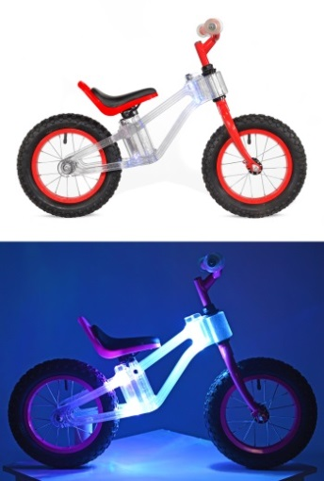
- KaZAM introduces fun and function with a twist - a new spin on balance bikes. The KaZAM Blinki Bike is sure to delight young riders and all the kids in the neighborhood thanks to an array of bright lights that blink as a child coasts on this balance bike.
- Designed without pedals, the Blinki Bike allows young children to skip the training wheels and develop their balance before introducing pedaling, making the transition onto traditional bikes seamless.
- Children everywhere will glow with delight riding the KaZAM Blinki Bike featuring a super strong frame made of space age clear polycarbonate material that lights up in multiple colors. Kids can also choose the color of their bike (handlebars, seat, rims), which is available in pink, purple, red and black. The frames on the pink and purple bikes also have a beautiful glitter effect.
- The LED light insert is flashing multi-colors, adding flair to a child’s ride!
- Batteries not included (6 AA)
- MSRP: $99
- Availability: October 2016
- Recommended Age: 2+

# # #

